**VIVEKANAND EDUCATION SOCIETY’S INSTITUTE OF TECHNOLOGY**

**An Autonomous Institute Affiliated to University of Mumbai**

**Department of Computer Engineering**



Project Report on

CDSS Based Mobile Application for Stroke Assistance

In partial fulfillment of the Fourth Year, Bachelor of Engineering (B.E.) Degree in Computer Engineering at the University of Mumbai Academic Year 2023-24

**Submitted by**

Manasi Shah - D17A - 61

Kaushik Sahasranam - D17A - 31

Chaitanya Sondur - D17A - 66

Riya Nadagire - D17A - 48

**Project Mentor**

Dr. Mrs. Gresha Bhatia

(2023-24)

**VIVEKANAND EDUCATION SOCIETY’S INSTITUTE OF TECHNOLOGY**

**An Autonomous Institute Affiliated to University of Mumbai**

**Department of Computer Engineering**



**Certificate**

This is to certify that **Manasi Shah(D17A, 61), Kaushik Sahasranaman (D17A, 31), Chaitanya Sondur (D17A, 66), Riya Nadagire (D17A, 48*)*** of Fourth Year Computer Engineering studyingunder the University of Mumbai have satisfactorily completed the project on “**CDSS Based Mobile Application for Stroke Assistance** ” as a part of their coursework of PROJECT-II for Semester-VIII underthe guidance of their mentor **Dr. Mrs. Gresha Bhatia** in the year 2023-24.

This project report entitled **CDSS Based Mobile Application for Stroke Assistance** by ***Manasi Shah, Kaushik Sahasranaman, Chaitanya Sondur , Riya Nadagire*** is approved for the degree of **B.E. Computer Engineering**.

| Programme Outcomes | Grade |
| --- | --- |
| PO1,PO2,PO3,PO4,PO5,PO6,PO7,  PO8, PO9, PO10, PO11, PO12  PSO1, PSO2 |  |

Date:

Project Guide: Dr. Mrs Gresha Bhatia

------------------------------------------

**Project Report Approval** **For**

**B. E (Computer Engineering)**

This project report entitled **CDSS Based Mobile Application for Stroke Assistance** by ***Manasi Shah, Kaushik Sahasranaman, Chaitanya Sondur , Riya Nadagire*** is approved for the degree of **B.E. Computer Engineering.**

Internal Examiner

-------------------------------------------

External Examiner

-------------------------------------------

Head of the Department

---------------------------------------------

Principal

---------------------------------------------

Date: 10/04/24

Place: Mumbai

**Declaration**

We declare that this written submission represents our ideas in our own words and where others' ideas or words have been included, we have adequately cited and referenced the original sources. We also declare that we have adhered to all principles of academic honesty and integrity and have not misrepresented or fabricated or falsified any idea/data/fact/source in our submission. We understand that any violation of the above will be cause for disciplinary action by the Institute and can also evoke penal action from the sources which have thus not been properly cited or from whom proper permission has not been taken when needed.

----------------------------------------- -----------------------------------------

Manasi Shah(61) Kaushik Sahasranman(31)

----------------------------------------- -----------------------------------------

Chaitanya Sondur(66) Riya Nadagire(48)

Date:10/04/24

**ACKNOWLEDGEMENT**

We are thankful to our college Vivekanand Education Society’s Institute of Technology for considering our project and extending help at all stages needed during our work of collecting information regarding the project.

It gives us immense pleasure to express our deep and sincere gratitude to Deputy Head of Department **Dr. (Mrs.) Gresha Bhatia** for her kind help and valuable advice during the development of projectsynopsis and for her guidance and suggestions.

We are deeply indebted to Head of the Computer Department **Dr. (Mrs.) Nupur Giri** and our Principal **Dr.** **(Mrs.) J. M. Nair ,** for giving us this valuable opportunity to do this project.

We express our hearty thanks to them for their assistance without which it would have been difficult in finishing this project synopsis and project review successfully.

We convey our deep sense of gratitude to all teaching and non-teaching staff for their constant encouragement, support and selfless help throughout the project work. It is a great pleasure to acknowledge the help and suggestion, which we received from the Department of Computer Engineering.

We wish to express our profound thanks to all those who helped us in gathering information about the project. Our families too have provided moral support and encouragement several times.

**Computer Engineering Department**

**COURSE OUTCOMES FOR B.E PROJECT**

Learners will be to,

| **Course Outcome** | **Description of the Course Outcome** |
| --- | --- |
| CO 1 | Able to apply the relevant engineering concepts, knowledge and skills towards the project. |
| CO2 | Able to identify, formulate and interpret the various relevant research papers and to determine the problem. |
| CO 3 | Able to apply the engineering concepts towards designing solutions for the problem. |
| CO 4 | Able to interpret the data and datasets to be utilized. |
| CO 5 | Able to create, select and apply appropriate technologies, techniques, resources and tools for the project. |
| CO 6 | Able to apply ethical, professional policies and principles towards societal, environmental, safety and cultural benefit. |
| CO 7 | Able to function effectively as an individual, and as a member of a team, allocating roles with clear lines of responsibility and accountability. |
| CO 8 | Able to write effective reports, design documents and make effective presentations. |
| CO 9 | Able to apply engineering and management principles to the project as a team member. |
| CO 10 | Able to apply the project domain knowledge to sharpen one’s competency. |
| CO 11 | Able to develop professional, presentational, balanced and structured approach towards project development. |
| CO 12 | Able to adopt skills, languages, environment and platforms for creating innovative solutions for the project. |

**Index**

| Chapter No. | Title | Page No. |
| --- | --- | --- |
| **1.** | **Introduction** | 10-12 |
| 1.1 | Introduction to the project | 10 |
| 1.2 | Motivation for the project | 10 |
| 1.3 | Problem Definition | 11 |
| 1.4 | Existing Systems | 11 |
| 1.5 | Lacuna of existing systems | 11 |
| 1.6 | Relevance of project | 12 |
| **2.** | **Literature Survey** | 13-23 |
| A | Brief Overview of Literature Survey | 13 |
| 2.1 | Research Papers  a. Abstract of the research paper  b. Inference drawn from the paper | 13-20 |
| 2.2 | Patent Search  a. Title of the patent and year of the patent  b. Summary of the patent  c. Link 1. European Patent: http://worldwide.espacenet.com/,  Link 2. Google Patents: https://patents.google.com/ | 20-21 |
| 2.3 | Inference Drawn | 22 |
| 2.4 | Comparison with Existing Systems | 22 |
| **3.** | **Requirement Gathering for proposed System** | 24-26 |
| 3.1 | Introduction to Requirement Gathering | 24 |
| 3.2 | Functional Requirements | 24 |
| 3.3 | Non-Functional Requirements | 24 |
| 3.4 | Hardware, Software, Technology and tools utilized | 25 |
| 3.5 | Constraints | 26 |
| **4.** | **Proposed Design** | 27-30 |
| 4.1 | Block diagram of the system | 27 |
| 4.2 | Modular design of the system | 28 |
| 4.3 | Detailed Design (Flowchart) | 29 |
| 4.4 | Project Scheduling &amp; Tracking using Timeline / Gantt Chart | 30 |
| **5.** | **Implementation of Proposed System** | 31-34 |
| 5.1 | Methodology employed for development | 31 |
| 5.2 | Algorithms and flowcharts for the respective modules developed | 31 |
| 5.3 | Datasets source and utilization | 33 |
| **6.** | **Testing of the Proposed System** | 35-40 |
| 6.1 | Introduction to testing | 35 |
| 6.2 | Types of tests Considered | 35 |
| 6.3 | Various test case scenarios considered | 36 |
| 6.4 | Inference drawn from the test cases | 38 |
| **7** | **Results and Discussions** | 41-46 |
| 7.1 | Screenshots of UserInterface(UI) for respective module | 41 |
| 7.2 | Performance Evaluation measures | 43 |
| 7.3 | Input Parameters / Features considered | 44 |
| 7.4 | Comparison of results with existing systems | 45 |
| 7.5 | Inference drawn | 46 |
| **8.** | **Conclusion** | 47-48 |
| 8.1 | Limitations | 47 |
| 8.2 | Conclusion | 47 |
| 8.3 | Future Scope | 47 |
|  | **References** | 49 |
|  | **Appendix** |  |
| **1** | **Paper 1** |  |
| a | Paper 1 |  |
| b | Plagiarism Report of Paper I |  |
| c | Project review sheet |  |

**List of Figures**

| Fig No. | Heading | Page No. |
| --- | --- | --- |
| 4.1 | Block Diagram | 27 |
| 4.2 | Modular Diagram of System | 28 |
| 4.3 | Detailed Diagram | 29 |
| 4.4 | Gantt Chart | 30 |
| 5.1 | Stroke detection flowchart | 32 |
| 5.2 | Flowchart of ANOVA feature selection | 32 |
| 5.3 | Random Forest Tree Depth 2 | 33 |
| 5.4 | Kaggle dataset | 34 |
| 5.5 | Mendeley dataset | 34 |
| 6.1 | Test case 1 | 36 |
| 6.2 | Test case 2 | 37 |
| 6.3 | Test case 3 | 37 |
| 6.4 | Test case 4 | 38 |
| 6.5 | Inference of test case 1 | 38 |
| 6.6 | Inference of test case 2 | 39 |
| 6.7 | Inference of test case 3 | 39 |
| 6.8 | Inference of test case 4 | 40 |
| 7.1 | Screen : Stroke assessment prediction | 41 |
| 7.2 | Screen : Diary Logs for each day | 41 |
| 7.3 | Screen : Schedule appointment with doctor | 42 |
| 7.4 | Electronic Health Records | 42 |
| 7.5 | Screen : Add Medicine functionality for doctor | 43 |
| 7.6 | Screen : Reschedule appointment | 43 |
| 7.7 | Accuracy of all models | 43 |
| 7.8 | Precision -Recall Graph | 44 |
| 7.9 | Feature Selection | 45 |

# Abstract

Stroke is a prominent global health issue, ranking as the leading cause of disability and the second leading cause of death. Stroke is a major cause of disability and death worldwide, with significant social and economic implications. It is a debilitating and potentially fatal disorder caused by a reduction or cessation of blood circulation to the brain, which damages or kills brain cells. The rising number of stroke survivors needs enhanced neurorehabilitation procedures. In response to the growing number of stroke survivors and the critical need for effective therapies, a Clinical Decision Support System (CDSS) mobile app is being created to transform stroke care. The software combines innovative technology with medical experience to expedite decision-making workflows for healthcare workers, addressing the critical requirement for quick and accurate interventions in stroke management. Focusing on stroke severity assessment, evidence-based protocol implementation, and personalized patient care, the app provides real-time access to critical information and diagnostic support. Additionally, it encompasses features such as risk assessment, medication management, telestroke consultations, and personalized rehabilitation planning. The CDSS app not only serves as a reliable companion for clinicians but also fosters interdisciplinary collaboration, facilitates telehealth consultations, and encourages continuous learning through data analytics. By offering real-time access to critical information and diagnostic support, along with features like risk assessment, medication management, telestroke consultations, and personalized rehabilitation planning, the CDSS app aims to bridge gaps in stroke care delivery, enhance patient outcomes, and advance healthcare practices.

# Chapter 1: Introduction

## 1.1 Introduction

Stroke is the second highest cause of disability in the world and it is the commonest cause of death.The World Stroke Organisation reports that, around 13 million people worldwide suffer a stroke each year leading to 5.5 million deaths. It should be noted also that stroke affects a higher percentage of people aged above 40 years than any other population category and hypertension is a major risk factor for this condition. As per Global Stroke Factsheet 2022, lifetime risk for stroke has gone up by 50% over the last seventeen years and therefore, one in four persons may have such trouble within their lifetime.Modifiable risk factors such as high blood pressure tobacco use and obesity are significant contributors to its occurrence. The causes range from unhealthy lifestyles like lack of exercise or unhealthy eating habits to genetic predispositions as well as environmental aspects like air pollution. For proper stroke prevention and treatment, it must be detected early. Stroke still poses a big problem in spite of the advances made in medical technology and treatment methods because there are delays in diagnosing, detecting, and giving appropriate treatments for the same. One potent approach to solving this is through the adoption of a Computerized Clinical Decision Support System (CDSS) which uses state-of-the-art technologies like Artificial Intelligence (AI) and Machine Learning. By integrating patient data, clinical imaging or evidence-based guidance, CDSS can help healthcare providers make timely, accurate decisions resulting in improved stroke outcomes. Also mobile health apps as well as telemedicine platforms may bring stroke care closer to people living in remote areas thus leading to faster intervention and rehabilitative services.

## 1.2 Motivation for the project

The staggering statistics surrounding stroke, its increasing prevalence, and the challenges in early detection and treatment highlight the urgent need for innovative solutions. By harnessing the power of cutting-edge technologies like Artificial Intelligence (AI) and Machine Learning, a Computerized Clinical Decision Support System (CDSS) holds immense promise in revolutionizing stroke care. This project aims to address the critical gaps in stroke prevention and treatment by leveraging CDSS to enable timely and accurate decision-making for healthcare providers. Through the integration of patient data and evidence-based guidance, CDSS offers a lifeline in improving stroke outcomes. Additionally, the utilization of mobile health apps and telemedicine platforms extends the reach of stroke care, particularly to underserved populations, ensuring faster intervention and access to rehabilitative services.

## 1.3 Problem Definition

The focus of our work is to address current issues in stroke care­ through building a mobile app for a Clinical Decision Support System (CDSS). The app is made to streamline decision-making for healthcare professionals involved in stroke management. Including important factors like gender, age, and smoking, among others, the app offers help anytime, assesses risks, and gives customized advice. These functions aim to greatly improve how well and fast stroke care works.

## 1.4 Existing Systems

Many important studies and model-building projects have been undertaken to detect strokes or determine the likelihood of a stroke using a variety of machine-learning approaches using patient datasets and electronic health information. As a result, we conducted important research that provided us with clarity and direction when carrying out our duties. This motivated us to interact with doctors and seek their guidance, consult published articles, and take into account numerous other viewpoints that significantly advanced our understanding and helped streamline our work. As a result, we developed a thorough study on the referred papers that are briefly described below, based on the objective, observation, evaluation metrics, and system development.

## 1.5 Lacuna of Existing System

1. Data Quality and Integration: The effectiveness of CDSS heavily relies upon the best integration of affected person information from various assets. Incomplete or faulty records can result in misguided predictions or recommendations.
2. Algorithmic Bias and Generalizability: Machine studying algorithms utilized in CDSS may show off bias or lack generalizability, particularly if skilled in confined or biased datasets. This can bring about faulty hazard assessments or treatment pointers, particularly for underrepresented affected person populations.
3. Usability Issues and Poor User Interface Design: Usability issues or negative user interface design in CDSS can avert consumer adoption and attractiveness. Healthcare providers may also find it bulky or time-ingesting to navigate through the machine, lowering its effectiveness in clinical exercise.

## 1.6 Relevance of the project

Artificial Intelligence and Machine Learning are booming in this internet age. It provides innovative solutions for stroke care by analyzing patient data to detect risk factors and patterns, enabling early intervention and personalized treatments. These technologies also assist healthcare professionals in making timely decisions, enhancing patient outcomes, and reducing disability burdens.

# 

# Chapter 2 : Literature Survey

**A. Brief Overview of Literature Survey**

Many important studies and model building projects have been undertaken to detect strokes or determine the likelihood of a stroke occurring using a variety of machine learning approaches using patient datasets and electronic health information. As a result, we conducted important research that provided us with clarity and direction when carrying out our duties. This motivated us to interact with doctors and seek their guidance, consult published articles, and take into account numerous other viewpoints that significantly advanced our understanding and helped streamline our work. As a result, we developed a thorough study on the referred papers that is briefly described below, based on the objective, observation, evaluation metrics, and system development.

The study examined a variety of publications and systematic reviews on stroke management, CDSS performance, and prediction models, with an emphasis on the use of machine learning approaches to improve diagnosis and therapy. Key factors such as age, heart disease, hypertension, and glucose levels were identified in multiple investigations. The creation of "Neuro Native," a user-friendly CDSS mobile app, aims to address challenges in stroke care by providing real-time support, risk assessment, and personalized recommendations to healthcare professionals, streamlining decision-making and improving stroke management efficiency and effectiveness.

## 2.1 Research Papers

Below are the research papers meticulously considered, reviewed and studied, contributing significantly to the refinement and development of our approach towards creating the Neuro Native app. These papers have served as guiding lights, shaping our understanding and strategies in addressing the challenges of stroke care. Through careful examination of these scholarly works, we have gained invaluable insights that have informed our decision-making processes and propelled us towards crafting a user-friendly Clinical Decision Support System (CDSS) mobile application. By leveraging the wealth of knowledge distilled from these studies, we aim to enhance stroke management practices and optimize patient outcomes through innovative capabilities of ‘Cognitive’.

**1. L. Souza-Pereira, N. Pombo, S. Ouhbi, and V. Felizardo, “Clinical decision support systems for chronic diseases: A Systematic literature review,” Computer Methods and Programs in Biomedicine, vol. 195, p. 105565, Oct. 2020, doi: 10.1016/j.cmpb.2020.105565.**

a. Abstract: A Clinical Decision Support System (CDSS) aims to assist physicians, nurses, and other professionals in decision-making related to the patient’s clinical condition. CDSSs deal with pertinent and critical data, and special care should be taken in their design to ensure the development of usable, secure, and reliable tools. This paper investigates existing literature dealing with the development process of CDSSs for monitoring chronic diseases, analyzing their functionalities and characteristics, and the software engineering representation in their design. A systematic literature review (SLR) analyzed CDSS literature for chronic diseases, revealing that diabetes was the most addressed disease (42.8%) with a focus on diagnostic approaches (85.7%). Data sources included databases (85.7%), sensors (42.8%), and self-reports (28.6%). Behavior diagrams (42.8%) and Structural diagrams (35.7%) were commonly used in system design, with a smaller percentage considering requirement specification (21.4%). Evaluation focused on system performance (64.2%), with accuracy as the primary metric (57.1%). In conclusion, software engineering techniques have limited representation in CDSS development for chronic diseases.

b. Inference: This paper conducted a systematic review on stroke management and CDSS effectiveness, focusing on diagnostic approaches. CDSS systems, depicted through diagrams, enhanced clinical decision-making with machine learning techniques like SVM, ANN, and RF. Application scope covers follow-up, prevention, diagnosis, treatment, and guideline management. Performance evaluation considers functional and non-functional requirements, including accuracy, sensitivity, specificity, completeness, precision, and F1-score.

**2. S. Dev, H. Wang, C. S. Nwosu, N. Jain, B. Veeravalli, and D. John, “A predictive analytics approach for stroke prediction using machine learning and neural networks,” Healthcare Analytics, vol. 2, p. 100032, Nov. 2022, doi: 10.1016/j.health.2022.100032.**

a. Abstract: Efforts to enhance stroke management and diagnosis have intensified due to its significant societal impact. Through the integration of technology and medical diagnosis, caregivers aim to improve patient care by systematically analyzing and storing medical records. This paper examines the relationship between various factors in electronic health records to predict strokes effectively. By employing statistical techniques and principal component analysis, we pinpoint age, heart disease, average glucose level, and hypertension as the key predictors of stroke. A perceptron neural network utilizing these four attributes achieves superior accuracy and lower miss rates compared to using all available input features and other algorithms. Due to dataset imbalance, we present results on a balanced dataset created via sub-sampling techniques.

b. Inference: This paper stresses enhanced patient management via systematic mining of medical records for stroke prediction. Key factors like age, heart disease, hypertension, and glucose levels in EHR are highlighted. Correlation analysis and PCA are used to identify relevant features. Models such as Neural Networks, Random Forest, and Decision Tree were evaluated. Random Forest demonstrated the highest accuracy, depicted by a bell curve plot.

**3.** **T. Tazin, N. Alam, N. N. Dola, M. S. Bari, S. Bourouis, and M. M. Khan, “Stroke disease detection and prediction using robust learning approaches,” Journal of Healthcare Engineering, vol. 2021, pp. 1–12, Nov. 2021, doi: 10.1155/2021/7633381.**

a. Abstract: Stroke, a serious medical condition caused by ruptured blood vessels in the brain, can lead to brain damage when blood supply is disrupted. Recognizing stroke warning signs early can mitigate its severity. This study, acknowledging stroke's global impact as a leading cause of death and disability, employs various machine learning (ML) models to predict stroke likelihood. Utilizing physiological parameters and ML algorithms such as Logistic Regression, Decision Tree Classification, Random Forest Classification, and Voting Classifier, four models were trained for prediction. Random Forest emerged as the most effective algorithm, achieving approximately 96% accuracy. The study utilized the open-access Stroke Prediction dataset, surpassing previous studies' accuracy percentages, signifying enhanced reliability. Extensive model comparisons validate their robustness, providing valuable insights for future analyses.

b. Inference: This scholarly work delves into the use of Open Access Data for studying brain stroke diagnosis and prognosis, highlighting a gap in research focus compared to heart stroke. SMOTE pre-processing balances datasets and manages outliers. Validation sets are advocated to prevent overfitting. Various algorithms like Random Forest, Decision Tree, and Logistic Regression were evaluated with explanation diagrams and confusion matrices. Histograms visualize data based on gender, age, BMI, glucose levels, and hypertension. Color scales are utilized to indicate parameters' contributions to stroke occurrence. Random Forest exhibits the highest accuracy, although other studies note limitations, citing a 73\% accuracy based on dataset specifics.

**4.**  **C. S. Nwosu, S. Dev, P. Bhardwaj, B. Veeravalli, and D. John, “Predicting Stroke from Electronic Health Records,” Jul. 2019, doi: 10.1109/embc.2019.8857234.**

a. Abstract: Numerous studies have pinpointed several risk factors contributing to stroke occurrence in individuals. While data mining techniques have been employed to predict strokes using patient medical records, there's been limited exploration of electronic health records to understand the interconnectedness of stroke risk factors. This paper conducts an analysis of electronic health records to assess the influence of risk factors on stroke prediction. Additionally, we present benchmark performances of cutting-edge machine learning algorithms in this domain.

b. Inference: This paper focuses on parameter determination for stroke prediction using EHR data. Various patient attributes including age, gender, hypertension, heart disease, marital status, occupation, residence type, glucose level, BMI, and smoking status were considered. Principal Component Analysis was employed, with each attribute's importance depicted diagrammatically by arrow lengths. Neural Network emerged as the best-performing model with 75.0% accuracy.

**5. A. Bivard and M. Parsons, “Artificial intelligence for decision support in acute stroke current roles and potential,” Nature Reviews Neurology, vol. 16, no. 10, pp. 575–585, Aug. 2020, doi: 10.1038/s41582-0200-390-y.**

a. Abstract: The management of stroke patients is becoming more intricate with the advent of new treatment options and evolving understandings of disease-treatment relationships. Clinicians must continually update their skills, stay abreast of literature, and integrate advancements into practice. Artificial intelligence (AI) offers promise in supporting clinical decision-making, potentially reducing variability among clinicians and aiding in vital information extraction for stroke patient identification, treatment prediction, and outcomes. Such AI systems could benefit centers with fewer stroke cases or serve as aids in discussions with patients and families. Moreover, AI-driven image processing and interpretation could equip any clinician with expert-level imaging assessments. However, AI systems should allow for expert clinician oversight to identify potential errors. This review underscores the growing role of imaging in stroke management and examines the potential benefits and challenges of AI-assisted treatment decision support in acute stroke.

b. Inference: The paper by Bivard and Parsons presents comprehensive figures and metrics showcasing the accuracy and performance of artificial intelligence (AI) in acute stroke decision support. These include graphical representations of algorithm accuracy, such as ROC curves and precision-recall curves, elucidating AI's diagnostic prowess and its ability to distinguish stroke cases effectively. Confusion matrices offer a detailed breakdown of algorithm performance, while comparative tables summarize accuracy, sensitivity, and specificity across studies. These visual aids highlight AI's transformative potential in streamlining stroke management, guiding timely interventions, and ultimately improving patient outcomes. Moreover, the paper underscores ongoing research efforts to refine AI algorithms and address challenges like data privacy.

**6. E. M. Alanazi, A. Abdou, and J. Luo, “Predicting risk of stroke from lab tests using machine learning algorithms: Development and evaluation of prediction models,” JMIR Formative Research, vol. 5, no. 12, p. e23440, Dec. 2021, doi: 10.2196/23440.**

a. Abstract: Stroke, a leading cause of death, imposes significant burdens on patients and healthcare systems. Health-related behavior is a crucial stroke risk factor, increasingly targeted for prevention efforts. While many machine learning models predict stroke risk or diagnose stroke using lifestyle factors or imaging, none incorporate lab test data. This study aims to predict stroke using machine learning techniques applied to lab test data from the National Health and Nutrition Examination Survey. Three data selection methods were employed: without resampling, with imputation, and with resampling. Four machine learning classifiers and six performance measures evaluated model performance. Results indicate accurate and sensitive stroke prediction from lab test data, with the resampling approach outperforming others. The random forest algorithm achieved the highest accuracy (0.96), sensitivity (0.97), specificity (0.96), positive predictive value (0.75), negative predictive value (0.99), and area under the curve (0.97) when using all attributes. The predictive model, utilizing lab test data, demonstrates ease of use and high accuracy.

b. Inference: In this study, a dataset of 512,726 participants was analyzed, focusing on lifestyle factors and physical features. Findings revealed that stroke occurrence correlated with age, heart disease, diabetes, and hypertension, with higher prevalence among older individuals. Men exhibited a higher stroke rate (9.5%) than women (7.9%). Variations in stroke incidence were observed across different geographical regions studied. The future scope suggests employing AI for automating tasks like image analysis and developing new tools for diagnosis and treatment, allowing clinicians to prioritize patient care.

**7. S. F. Alasiri, A. Douiri, S. Altukistani, T. Porat, and O. Mousa, "The Role of Clinical Decision Support Systems in Preventing Stroke in Primary Care: A Systematic Review," *Perspect Health Inf Manag.*, vol. 20, no. 2, p. 1d, Apr. 2023.**

a. Abstract: Computerized clinical decision support systems (CDSS) play a crucial role in assisting clinicians with complex decision-making processes. This systematic review assesses the evidence regarding CDSS developed and tested for supporting decision-making in primary healthcare for stroke prevention, along with barriers to their practical implementation. A systematic search of various databases was conducted, yielding five studies, both experimental and observational, for synthesis. The review indicates that CDSS aids decision-making in primary healthcare settings for stroke prevention. Nonetheless, barriers were identified in the design, implementation, and utilization of CDSS, highlighting areas for improvement in their practical application.

b. Inference: This paper underscores the efficacy of Clinical Decision Support Systems (CDSS) in enhancing decision-making processes in healthcare, particularly in stroke management. While acknowledging the barriers in designing, implementing, and utilizing CDSS, it emphasizes the system's significant contributions to diagnosis, patient management, alerts and reminders, individualized assessment, and interventional recommendations. By providing statistics on the escalating stroke incidence and its lethal consequences, the paper underscores the urgency to improve preventive, diagnostic, and prescriptive health processes. Focusing on three core aspects of CDSS tools—user interface, processing layer, and data management layer—it conducts a comprehensive analysis considering factors such as age, gender, medical history, lifestyle, and biomarkers like BMI and cholesterol levels. Moreover, it highlights the pivotal role of prompt recognition and action in mitigating stroke damage, paving the way for more effective stroke prevention and management strategies.

**8. M. Chun et al., “Stroke risk prediction using machine learning: a prospective cohort study of 0.5 million Chinese adults,” Journal of the American Medical Informatics Association, vol. 28, no. 8, pp. 1719–1727, May 2021, doi: 10.1093/jamia/ocab068.**

a. Abstract: This study aims to compare Cox models, machine learning (ML), and ensemble models combining both approaches for predicting stroke risk in a prospective study of Chinese adults. Using data from 503,842 adults without prior stroke history, various models were evaluated over different follow-up intervals. Inputs included sociodemographic factors, diet, medical history, physical activity, and measurements. Compared were Cox regression, logistic regression, support vector machines, random survival forests, gradient boosted trees (GBT), and multilayer perceptrons, against the Framingham Stroke Risk Profile. GBT exhibited the best discrimination and calibration for 9-year stroke risk prediction. An ensemble approach combining GBT and Cox models yielded higher accuracy, specificity, and positive predictive value. This suggests the potential value of incorporating machine learning into clinical practice for identifying individuals at high risk of stroke.

b. Inference: In a prospective study of Chinese adults, various models including Cox regression, logistic regression, support vector machines, random survival forests, gradient boosted trees (GBT), and multilayer perceptrons were compared for stroke risk prediction. Gradient boosted trees (GBT) demonstrated the best discrimination and calibration for 9-year stroke risk prediction, consistently outperforming other models across follow-up intervals. An ensemble approach combining GBT and Cox models achieved higher accuracy, specificity, and positive predictive value in identifying individuals at high risk of stroke (>10% predicted 9-year stroke risk). These findings underscore the potential of machine learning (ML) techniques, particularly ensemble models, in enhancing stroke risk prediction in clinical practice.

**9. M. Saxena, M. Choudhary, M. Deep, S. Bhamra, and M. Maru, “Issue 4 www.jetir.org (ISSN-2349-5162),” JETIR2204518 Journal of Emerging Technologies and Innovative Research, vol. 9, 2022.**

a. Abstract: A stroke, also referred to as a cerebrovascular accident (CVA), occurs when a portion of the brain loses its blood supply, leading to dysfunction in the corresponding part of the body. This loss can result from either ischemia, due to insufficient blood flow, or hemorrhage, caused by bleeding into brain tissue. As strokes can lead to death or permanent disability, they are considered medical emergencies. Treatment for ischemic strokes is most effective when initiated within a few hours of symptom onset. Patients, family, or bystanders should promptly activate emergency medical services upon suspicion of a stroke. Transient ischemic attacks (TIAs), or mini-strokes, are short-lived ischemic strokes where symptoms resolve spontaneously and require urgent assessment to mitigate future stroke risk. According to the World Health Organization (WHO), stroke ranks as the second leading cause of global mortality, accounting for approximately 11% of total deaths. The machine learning model is utilized by them on a dataset focusing on gender, age, various diseases, and smoking status to predict stroke likelihood, emphasizing attributes with significant stroke risk factors.

b. Inference: The paper employs machine learning algorithms for predicting brain strokes. The authors utilize a variety of machine learning techniques such as Support Vector Machines (SVM), Artificial Neural Networks (ANN), Random Forest (RF), and possibly others to develop predictive models. Through rigorous experimentation and analysis of various features including demographic data, medical history, and biomarkers, they infer the most effective algorithm(s) for accurately predicting the occurrence of brain strokes. This collaborative research endeavors to harness the power of machine learning to enhance predictive healthcare interventions, thereby contributing to improved patient care and outcomes.

**10. E. Akay, A. Hilbert, B. Carlisle, V. I. Madai, M. A. Mutke, and D. Frey, “Artificial Intelligence for Clinical Decision Support in Acute Ischemic Stroke: A Systematic Review,” vol. 54, no. 6, pp. 1505–1516, Jun. 2023, doi: https://doi.org/10.1161/strokeaha.122.041442.**

a. Abstract: In the quest for improved treatment outcomes in acute ischemic stroke, there's been a shift towards utilizing artificial intelligence (AI) to tailor treatment decisions to individual patient characteristics. This systematic review examines AI-based clinical decision support systems in development for acute ischemic stroke, focusing on methodological robustness and constraints for clinical implementation. Out of 121 studies reviewed, 65 were included for detailed analysis. The heterogeneity in data sources, methods, and reporting practices underscores the challenges in standardization and clinical translation. Our findings highlight validity threats and emphasize the need for cohesive reporting standards in AI healthcare research. Practical recommendations are provided for successful integration of AI in acute ischemic stroke diagnosis and treatment.

b. Inference: The systematic review rigorously examines the role of artificial intelligence (AI) in clinical decision support for acute ischemic stroke. Through meticulous methodology, the authors assess various AI techniques including machine learning algorithms such as Support Vector Machines (SVM), Artificial Neural Networks (ANN), and Decision Trees, alongside clinical decision support systems. They evaluate these approaches' efficacy in diagnosing, treating, and predicting outcomes in acute stroke cases. The paper likely includes diagrams illustrating the workflow of AI-driven decision support systems and the integration of machine learning algorithms. Furthermore, it might feature comparative analyses showcasing the performance of different AI models in stroke management tasks. By synthesizing these findings, the review contributes to understanding how AI can enhance clinical decision-making processes in acute ischemic stroke, guiding future research and practice in the field.

## 2.2 Patent Search

1. **PATIENT CARE SURVEILLANCE SYSTEM AND METHOD ( CA2918332C)**

**Inventor** : Rubendar Amarasingham, Vidyanatha Siva , Monal Shah , Anand Shah , George Oliver , Praseetha Cherian, Javier Velazquez , Paul Mayer

A system for patient care surveillance includes a database for storing clinical and non-clinical data of patients, a user interface for inputting current patient information, a monitor for sensing patient parameters and generating real-time monitor data, an analysis module for analyzing data and identifying adverse events, and a presentation module for displaying information about adverse events to healthcare professionals, including contextual details.

1. **PATIENT DATA MANAGEMENT PLATFORM ( US20220375559A1)**

**Inventor** : John R , WHANNEL, Gregory D. Mears

A platform for managing patient data, like a community paramedicine system or mobile integrative health platform, encompasses web-based, cloud-based, or software-based systems. It tracks patients and their visits by healthcare providers or EMS professionals outside of hospitals, including non-emergency situations. This platform handles tasks such as data input, visit logging, and reporting, which differ from those of traditional EMS electronic patient care reporting systems

1. **CDSS MEDICAL ADVICE DATA QUERY OPTIMIZATION METHOD AND SYSTEM (CN117453732A )**

**Inventor** : Cai Zhicong; Guo Yipeng; Qiu Bin; Liu Zhijun; Zheng Zhikun; Lan Huiying; Li Chengyang

The CDSS medical advice data query optimization method and system enhance efficiency by revising SQL queries, caching and filtering results. This reduces database interactions, cuts network usage, and decreases query time. Consequently, medical advice quality control execution improves, interface concurrency rises, and clinical service interruptions shorten. This maximizes the CDSS's positive impact on clinical decision-making, reduces medical errors, and enhances overall medical quality.

1. **HEALTHCARE SUPPORT SERVER, HEALTHCARE SUPPORT METHOD AND COMPUTER READABLE PROGRAM (JP2019211824A)**

Inventor : KAMEGAYA MASANOBU

To enhance healthcare support content for individuals whose focus isn't primarily on healthcare, a healthcare support server is proposed. It comprises various storage units: one for attribute information of the healthcare recipient, another for integrated personality traits relevant to healthcare decision-making, one for health data, and another for bias algorithms. Additionally, there are storage units for survey items, behavior change stories, and guidance patterns tailored to the recipient's decision-making characteristics. These units collectively determine optimal communication strategies, aided by communication optimization processing analyzing ideal communication timings for effective engagement.

1. **INTEGRATION CLINICAL DECISION SUPPORTING SYSTEM AND METHOD THERBY (KR20150061456A)**

Inventor : LEE SUNG YOUNG [KR]; HUSSAIN MAQBOOL [PK]

The integrated clinical decision support system described herein comprises a CDSS application terminal tasked with gathering user medical information, encompassing medical records, social media insights, and sensor measurements. Additionally, an integrated clinical decision support unit is employed to standardize the acquired user medical data and formulate medical recommendations in accordance with predefined medical guidelines.

1. **DIAGNOSTIC DECISION SUPPORT FOR PATIENT MANAGEMENT (US2020075163A1)**

Inventor : BARKAN ELLA [IL]; REICHER MURRAY A [US]; WALACH EUGENIUSZ [IL]

A diagnostic manager processes a patient's health history to produce multiple probabilities associated with various medical conditions. It then formulates an initial list of potential diagnostic actions, determining their individual values and associated costs. Subsequently, the diagnostic manager computes scores for each diagnostic action on the initial list and suggests a recommended diagnostic course of action.

## 2.3 Inference Drawn

Integrating clinical decision support systems (CDSSs) into healthcare holds immense promise for improving patient care and outcomes by aiding clinicians in decision-making processes. However, challenges such as poor usability and integration issues have hindered their effectiveness in practice. To overcome these barriers, a cognitive fit design approach is advocated, which aligns CDSSs with clinicians' mental models and tasks, reducing cognitive load and enhancing usability. By adhering to cognitive fit design principles, CDSSs can better meet the needs and expectations of healthcare professionals, leading to improved acceptance and utilization.

Prototype testing, such as with a stroke CDSS, serves as a valuable validation step, demonstrating the feasibility and potential benefits of incorporating cognitive fit design principles into CDSS development. Usability testing of the prototype further confirms its acceptability, accuracy, and effectiveness in reducing cognitive burden, making it a preferred tool for clinicians. These positive outcomes underscore the importance of prioritizing usability and cognitive fit in CDSS design to optimize their impact on clinical practice.

Moreover, the successful implementation of CDSSs requires a multifaceted approach, encompassing not only technical aspects but also organizational and cultural considerations. Healthcare institutions must foster a culture that values and supports the integration of technology into clinical workflows, providing adequate training and resources for effective CDSS utilization.

Overall, the findings highlight the potential of cognitive fit design in addressing usability challenges and enhancing the effectiveness of CDSSs in healthcare settings. By aligning with clinicians' mental models and tasks, CDSSs can streamline decision-making processes, improve adherence to guidelines, and ultimately enhance patient care outcomes.

## 2.4 Comparison with Existing System

In comparison to existing Clinical Decision Support Systems (CDSSs), which often face criticism for their lack of user-friendliness and seamless integration into healthcare workflows, this study introduces a novel approach known as cognitive fit design. Traditional CDSSs, while valuable in providing clinical insights, often fail to align with the mental models and task processes of healthcare providers. As a result, they can be challenging to use and may not be fully adopted in clinical practice. Recognizing these limitations, this research focuses on leveraging cognitive fit theory to develop CDSSs that better match physicians' thought processes and work patterns.

By incorporating cognitive fit principles into the design process, the study aims to create CDSSs that are more intuitive and user-friendly for healthcare professionals. The proposed guidelines based on cognitive fit theory offer a structured framework for aligning CDSS functionality with the cognitive needs of physicians, ultimately enhancing usability and facilitating smoother integration into clinical workflows. This approach is expected to bridge the gap between CDSS capabilities and healthcare provider requirements, leading to more effective decision-making support in medical settings.

Furthermore, the research goes beyond theoretical considerations by implementing cognitive fit design principles in the development of a prototype CDSS, specifically targeting stroke management. Unlike traditional systems that may require significant cognitive effort to navigate and utilize, the prototype CDSS is designed to minimize cognitive load and optimize usability. Preliminary usability tests indicate positive feedback from healthcare professionals, suggesting that the CDSS aligns well with their mental models and workflow preferences. This practical demonstration underscores the potential of cognitive fit design in overcoming the usability challenges faced by existing CDSSs and improving their effectiveness in real-world clinical practice.

# Chapter 3: Requirement Gathering for the Proposed System

## 3.1 Introduction to Requirement Gathering

The Requirement Gathering is a process of requirements discovery or generating list of requirements or collecting as many requirements as possible by end users. It is also called as requirements elicitation or requirement capture.

The requirements gathering process consists of six steps :

* Identify the relevant stakeholders
* Establish project goals and objectives
* Elicit requirements from stakeholders
* Document the requirements
* Confirm the requirements
* Prioritize the requirements

## 3.2 Functional Requirements

The functional requirements for a Clinical Decision Support System for stroke care are:-

1. **Integration with Electronic Health Records (EHR)**: The CDSS should seamlessly integrate with existing EHR systems to access patient data, including medical history, laboratory results, imaging studies, and medication records.
2. **Clinical Alerts and Reminders**: The system should generate real-time alerts and reminders for healthcare providers regarding critical information, such as medication interactions, allergy warnings, abnormal test results, and preventive care recommendations.
3. **Diary Logs:** The system needs to have the capability to track and present the patient's health progress on a weekly basis, allowing for efficient monitoring by both the patient and the doctor.
4. **Stroke Risk Assessment:** The system should incorporate a mechanism to predict an individual's risk of stroke by utilizing user-inputted symptoms and other relevant factors.

## 3.3 Non-Functional Requirements

The functional requirements for a Clinical Decision Support System for stroke care are:-

1. **Security:** The CDSS should ensure the confidentiality, integrity, and availability of patient data, implementing robust authentication, encryption, and access controls to protect sensitive information from unauthorized access or breaches.
2. **Performance:** The system should be responsive and scalable, capable of handling large volumes of data and processing complex queries efficiently, to support real-time decision support and clinical workflow integration.
3. **Reliability:** The CDSS should be reliable and available 24/7, with minimal downtime or service interruptions, to ensure uninterrupted access to decision support tools and patient information when needed.
4. **Usability:** The system should be user-friendly and intuitive, with a well-designed interface and workflow that healthcare providers can easily navigate and incorporate into their clinical practice without significant training or effort.

## 3.4 Hardware, Software, Technology and Tools Utilized

**Hardware:-**

Intel Core i3 Processor or higher

Minimum 8GB RAM

Laptop / Android / IoS based Smart Phones

Windows/Linuc/MacOS Operating System

**Software:-**

Github - for collaboratory work

React Native (Version 0.72.6) - for mobile app development

Firebase (Version 18.7.3) - for storing patient records

Figma - wireframing and designing

Flask (Version 3.0) - To integrate a Machine Learning Model into the application

VS Code (Version 1.88) - Integrated Development Environment

## Techniques

1. **React Native:** React Native is an open-source framework developed by Facebook that allows developers to build mobile applications using JavaScript and React. It enables the creation of cross-platform apps for iOS and Android with a single codebase, saving time and effort. React Native utilizes native components rather than web views, resulting in apps that look and feel like native applications while still leveraging the power and flexibility of React for UI development.
2. **Firebase:** Firebase is a comprehensive platform developed by Google that provides a wide range of backend services and tools for building web and mobile applications. It offers features such as real-time database, authentication, cloud storage, hosting, machine learning, analytics, and more. Firebase allows developers to quickly develop high-quality apps without managing servers or infrastructure, making it an ideal solution for startups, small businesses, and even large enterprises.
3. **Python:** Python is a high-level, interpreted programming language known for its simplicity, readability, and versatility. Developed by Guido van Rossum and first released in 1991, Python has since become one of the most popular languages worldwide. It features a dynamic type system and automatic memory management, making it suitable for a wide range of applications, including web development, data science, artificial intelligence, automation, scientific computing, and more.
4. **Flask:** Flask is a lightweight and flexible web framework for Python, designed to make web development simple and scalable. It was created by Armin Ronacher and first released in 2010. Flask is known for its minimalistic approach, allowing developers to build web applications quickly and efficiently while providing the flexibility to scale up for larger projects.

## Tools

1. **VSCode:** Visual Studio Code (VSCode) is a free, open-source code editor developed by Microsoft. It's designed for developers and programmers working on various platforms, including Windows, macOS, and Linux. VSCode provides a rich set of features to enhance productivity and streamline the coding process.
2. **Github:** GitHub is an online software development platform. It's used for storing, tracking, and collaborating on software projects.It makes it easy for developers to share code files and collaborate with fellow developers on open-source projects. GitHub also serves as a social networking site where developers can openly network, collaborate, and pitch their work.

## 3.5 Constraints

1. Internet access is required.
2. Users should have basic technical knowledge to navigate through the application.
3. Users should have the ability to read graphs.

# Chapter 4: Proposed System

## 4.1 Block Diagram of the system

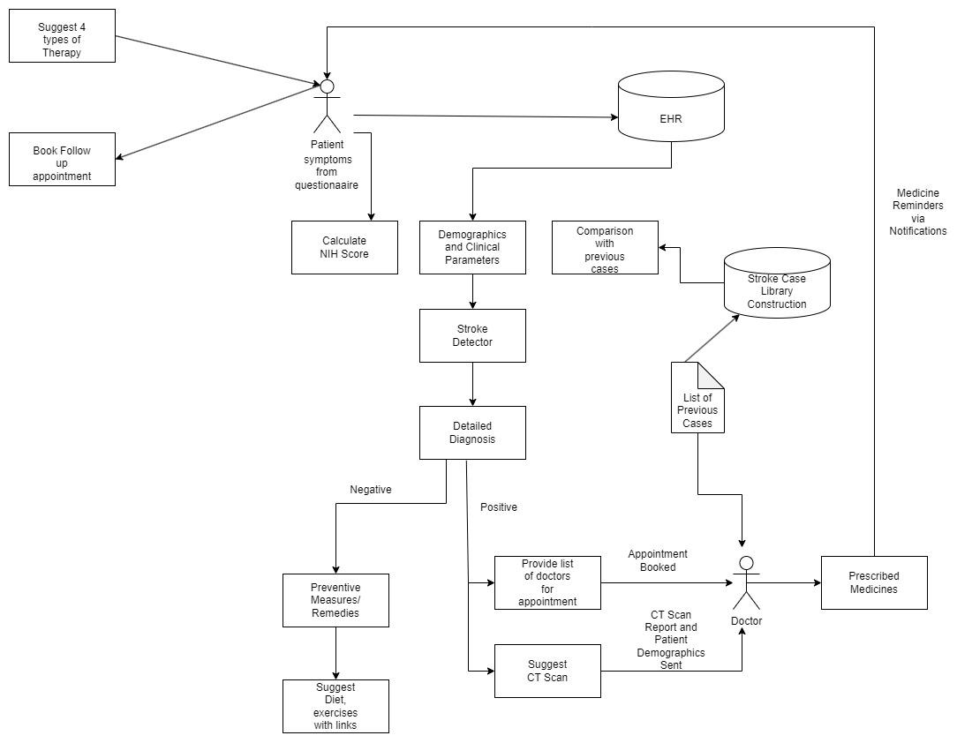

Fig. 4.1 Block Diagram

Upon accessing the app, patients are presented with a dashboard and prompted to complete a questionnaire as shown in figure 4.1 comprising basic questions aimed at predicting stroke risk. This prediction is based on demographic data, questionnaire responses, and expert advice from healthcare providers. The Clinical Decision Support System (CDSS) leverages previous cases, requisite parameters, and EHR data, employing machine learning algorithms to forecast stroke risk.

* If a patient is deemed to be at risk of stroke, they are offered the option to schedule an appointment. Conversely, patients with a stroke risk score of 0 receive recommendations for diet plans, therapy, and preventive measures.
* Appointment bookings are instantly visible to healthcare providers on their dashboard, allowing them to access patient profiles stored in the EHR.
* Each patient's Electronic Health Record (EHR) encompasses their stroke assessment questionnaire responses, health documents, and daily logs to track compliance with expert recommendations.
* Expert will provide recommendations based on the stroke risk of the patient and also examine the patient in person concerning other factors such as vision, attentiveness, responsiveness, among others.

## 4.2 Modular Design of system

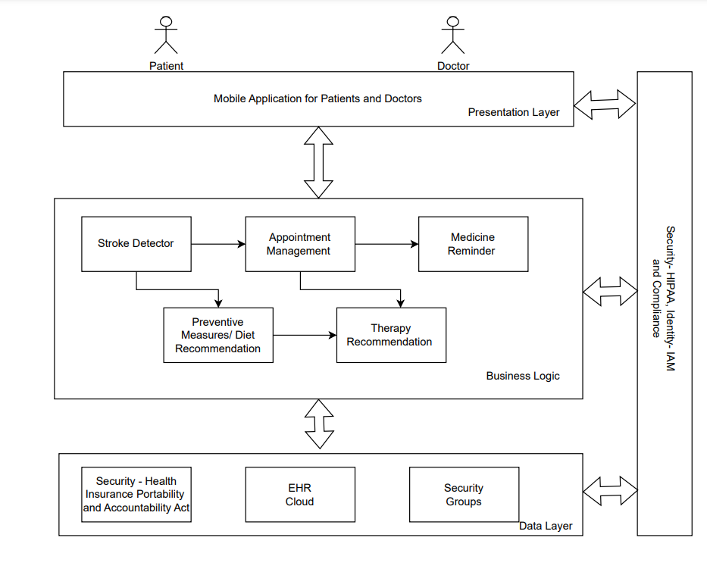

Fig 4.2 Modular Design of system

The system in figure 4.2 provides a clear overview of the user-friendly process for patients utilizing the app. It outlines crucial stages in stroke prevention and management, including patient registration, data collection,stroke risk assessments and personalized recovery plans. Utilizing decision support and care coordination, the CDSS facilitates timely interventions and patient education, thereby enhancing stroke prevention efforts in primary care settings. The app offers various functionalities and services tailored to patients, guiding them through the process of utilizing the application effectively.

* Unique Patient ID generated on registration.
* Patient answers Stroke assessment questionnaire.
* Answers are stored on the EHR cloud.
* The result of the diagnosis is displayed to the expert and patient books an appointment with expert for better care.
* Depending on the result, the patient is either recommended to book an appointment with an expert or suggest diet plans or preventive measures.
* After the appointment is booked, it is sent to the respective expert.
* The patient is sent reminders of his/her appointment.
* The patient can also book a follow-up appointment with the expert.

## 4.3 Detailed design (Flowchart)

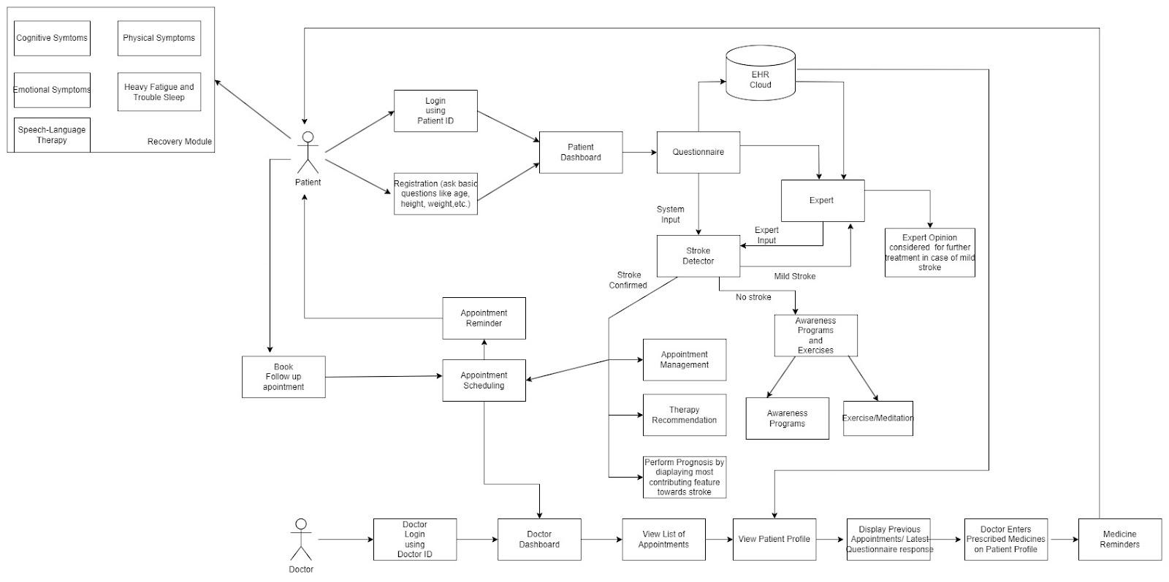

Fig. 4.3 Detailed design

The detailed explanation of each module of the application is illustrated in figure 4.3 which portrays the patient's journey login to evaluating stroke risk, booking appointments with experts, and managing daily tasks seamlessly. Patients log in securely to access their health information and complete a questionnaire assessing stroke risk. Those at risk can schedule appointments with healthcare experts for personalized consultations. The app facilitates daily task management, reminding patients to adhere to medication schedules, exercise routines, and dietary plans. Healthcare providers monitor patient progress and receive alerts, enabling timely interventions and follow-ups.

Patient:-

* Unique Patient ID generated on registration
* Ask basic questions like height, weight, BMI, Marital status, and Smoking habits.
* Patient answers Questionnaire
* Answers are stored on the EHR cloud
* The result of the diagnosis is displayed to the patient
* Depending on the result, the patient is either recommended diet plans or preventive measures or given a list of doctors for appointments.
* After the appointment is booked, it is sent to the respective doctor.
* The patient is sent reminders of his/her appointment.
* The patient can also book a follow-up appointment with the same doctor.

Doctor :

* The doctor can log in using a unique Doctor ID.
* A list of upcoming appointments is displayed on the dashboard.
* The doctor can view the profile of any patient and after the appointment, enter the prescribed medicines so that the patient is sent timely reminders for the same.

## 4.4 Project Scheduling & Tracking using Timeline / Gantt Chart

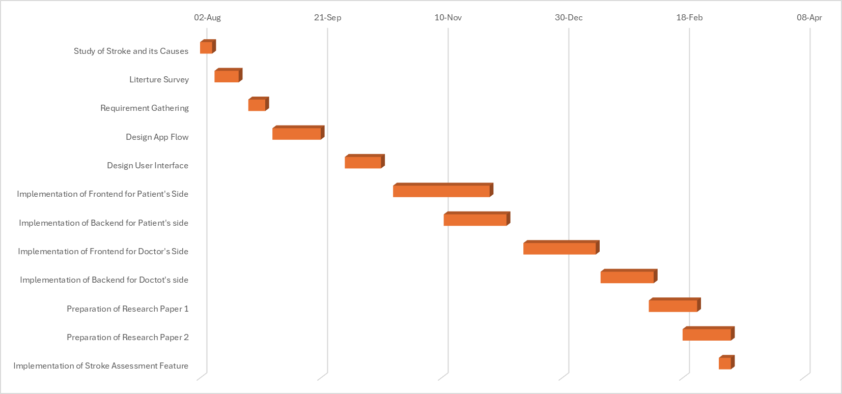

Fig. 4.4 Gantt Chart

The Gantt chart of our project where we worked for the whole semester to create this model is shown in a timeline pattern. It is the most important part to think and design the planning of your topic and so we planned our work like the gantt chart shown in figure 4.4.

# 

# Chapter 5: Implementation of Proposed System

## 5.1 Methodology employed for development

In developing the CDSS Stroke Assistance App, the integration of machine learning (ML) algorithms plays a pivotal role in accurately detecting stroke risk factors. ML algorithms analyze patient data collected through stroke assessments, enabling the identification of crucial risk factors associated with stroke occurrence. However, it's essential to emphasize that ML alone may not suffice, as expert opinion from healthcare professionals is equally indispensable. ML provides a systematic approach to identify patterns and trends, but human expertise adds valuable clinical insight and judgment to the decision-making process.

1. Stroke Assessment Module:

Utilizes ML algorithms to detect the presence of stroke based on essential risk factors. Analyzes patient data, including demographics, medical history, and symptoms, to generate a comprehensive stroke risk assessment report.

1. Daily Log Plan by Experts:

Upon receiving the stroke assessment report, healthcare experts provide a personalized daily log plan for patients.The daily log plan encompasses medication schedules, physical therapy routines, and dietary recommendations tailored to the patient's specific needs.Weekly reports are generated to track the patient's adherence to the prescribed daily log plan.

1. Appointment Booking System:

Patients have the option to schedule appointments with healthcare experts for regular check-ups and updates on their condition.The appointment booking system ensures timely access to healthcare professionals for ongoing monitoring and support.

1. Electronic Health Records (EHR) Repository:

The EHR serves as a centralized repository for storing all health documents, including stroke assessments, medical records, and diagnostic reports, for every patient.Enables easy access to comprehensive patient information for healthcare providers, facilitating informed decision-making and continuity of care.

By integrating ML-driven stroke assessment capabilities with expert guidance and personalized care plans, the CDSS Stroke Assistance App aims to enhance stroke prevention, management, and patient outcomes.

## 5.2 Algorithms and Flowcharts for the respective modules developed

Once the data preprocessing phase is completed, the next step involves training predictive models tailored for multiclass classification of stroke severity. This project employs three distinct algorithms: Logistic Regression, Random Forest, and Naive Bayes. Logistic Regression is a linear classification model that calculates the probability of each class based on input features. Random Forest, an ensemble learning technique, constructs a multitude of decision trees during training and combines their outputs to produce robust predictions for multiple classes. Naive Bayes relies on Bayes' theorem and assumes strong independence between features to classify instances probabilistically across different severity levels.

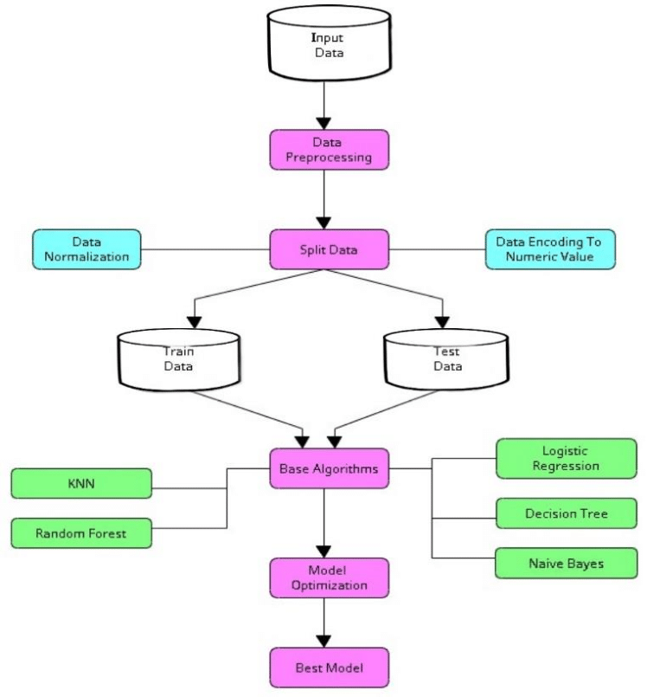

Fig. 5.1 Stroke detection flowchart

To predict a patient’s risk of having stroke, this project used machine learning (ML) approach on a stroke dataset obtained from Kaggle, the ANOVA (Analysis of Variance) feature selection method with and without the following three Classification procedures; Logistic Regression, Random forest, Naïve Bayes as shown in fig 5.2

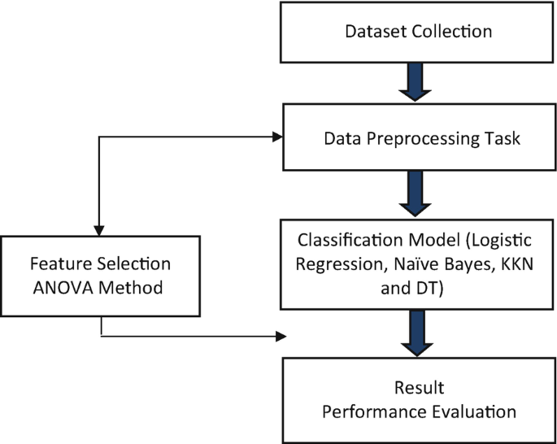

Fig 5.2 Flowchart of Stroke detection using ANOVA feature selection

For evaluating the performance of the Random Forest model, utilizing cross-validation with 15 folds, the accuracy of the model is evaluated, providing a comprehensive understanding of its predictive capabilities across various stroke severity levels. This meticulous evaluation ensures that only the most reliable and accurate models are deployed in CDSS applications, enhancing their effectiveness in predicting and managing stroke severity.

For instance, the top-level node is named "nihss less than equal to 0.10", indicating that the decision is based on the feature "nihss" being less than or equal to 0.10. If this condition is true, the tree proceeds to evaluate the conditions within the subsequent nodes, such as "bmi less than equal to 0.24" or "glucose less than equal to 0.93". Each node name encapsulates the specific feature and threshold used for splitting the data, providing insights into the decision-making process of the tree as depicted in figure. 5.1

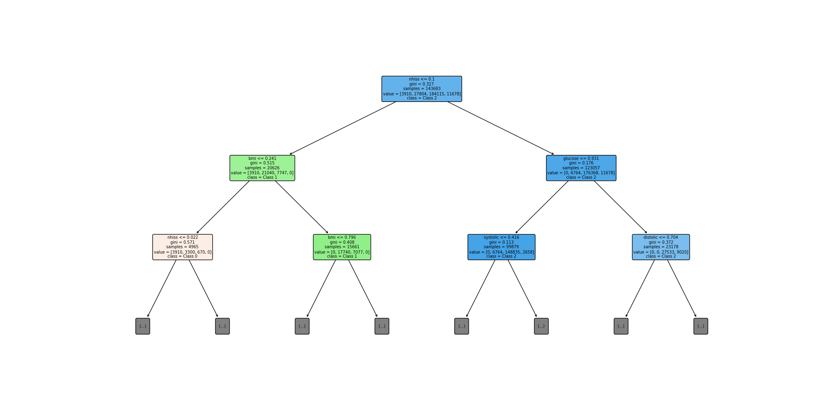

Fig 5.3 Random Forest Tree Depth 2

## 5.3 Dataset Source and Utilization

Acquiring a prepared dataset is vital for effectively leveraging deep learning models across various applications. However, sourcing top-tier datasets can be challenging. Deep learning algorithms rely heavily on dataset attributes and patterns for generating predictions, underscoring the importance of having a refined and well-prepared dataset. In a recent study, two stroke prediction datasets were merged to create a comprehensive dataset. One dataset, sourced from Kaggle, contained 5110 rows and 12 columns, while the second dataset, obtained from Mendeley, comprised 4798 rows and 15 columns. This merging was done to incorporate a wider range of demographic and health-related factors for more robust analysis. Fig. 4 provides a concise overview of the merged dataset, encompassing details such as gender, age, hypertension, heart disease, marital status, occupation, residence type, average glucose level, BMI, smoking status, and stroke occurrence.

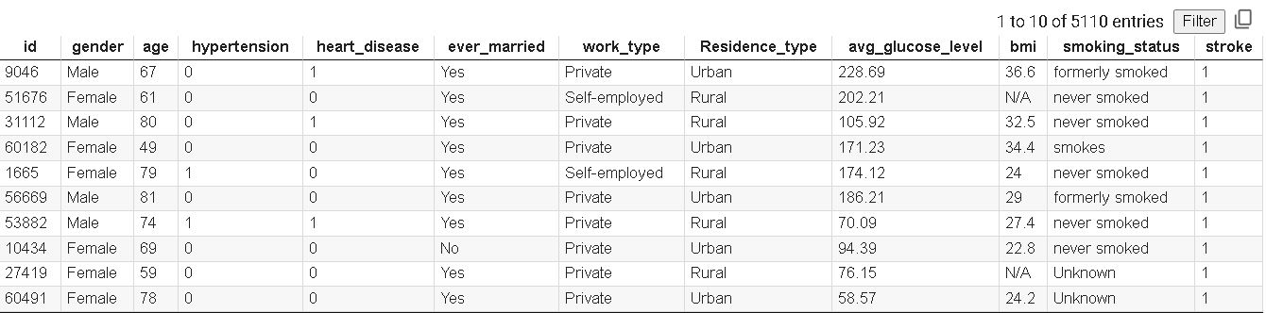

Fig. 5.4 Kaggle dataset

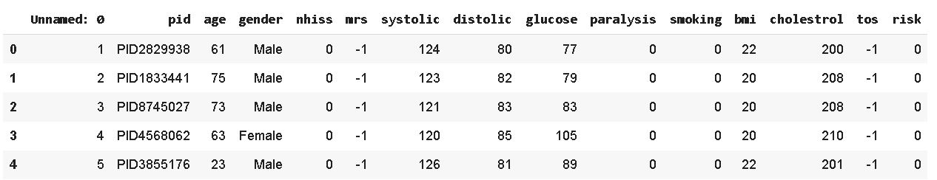

Fig. 5.5 Mendeley Dataset

# 

# Chapter 6: Testing of Proposed System

## 6.1 Introduction to Testing

Software testing is the sequence of activities that happen during software testing. By employing a sane software testing life cycle, an organization ends up with a quality strategy more likely to produce better results. Why is this so important, though? It all boils down to customer satisfaction. Presenting a perfect product to the customer is the end goal of every organization. Nothing puts off customers more than bug-filled user experience. So when enterprises realized this, they began to include testing as a mandatory part of the SDLC. Since then, testing has become an integral part of every organization.

Project Testing Phase means a group of activities designated for investigating and examining progress of a given project to provide stakeholders with information about actual levels of performance and quality of the project. It is an attempt to get an independent view of the project to allow stakeholders to evaluate and understand potential risks of project failure or mismatch. The purpose of the testing phase is to evaluate and test declared requirements, features, and expectations regarding the project prior to its delivery in order to ensure the project matches initial requirements stated in specification documents.

## 6.2 Types of tests considered

**A.Unit Testing**

Unit testing involves testing individual components or functions of the application in isolation to verify that they work as expected. In the context of our CDSS mobile app for stroke assistance, unit testing would entail testing each specific feature or module of the app, such as the stroke risk prediction algorithm, appointment booking functionality, or user authentication system.

The purpose of unit testing is to ensure that each component of the app functions correctly on its own, without dependencies on other parts of the system. By isolating and testing individual units of code, developers can identify and fix bugs or errors early in the development process, leading to a more stable and reliable application. Additionally, unit testing helps to improve code quality, maintainability, and reusability by promoting modular and well-structured code design. Overall, unit testing plays a crucial role in ensuring the overall quality and reliability of the CDSS mobile app for stroke assistance.

**B.Integration Testing**

Integration Testing ensures that individual components of the application, such as the user interface (UI), backend database, and various modules, interact correctly and harmoniously with each other when integrated. In the context of our CDSS mobile app for stroke assistance, this testing phase would involve verifying the communication and data flow between different parts of the application.

In the case of appointment scheduling, integration testing verifies the interaction between different components, such as the user interface (UI) and the backend database. This process ensures that appointment data entered by users through the UI is accurately transmitted and stored in the database, ready for retrieval and processing by other parts of the system.

Similarly, for login information, integration testing validates the communication between UI elements responsible for capturing user credentials and the authentication system that verifies and grants access to authorized users. By thoroughly testing this interaction, we ensure that users can securely log in to the app without encountering any errors or inconsistencies.

## 6.3 Various test case scenarios considered

Case 1: The input field for ‘phone' should only accept valid phone number as shown in fig. 6.1

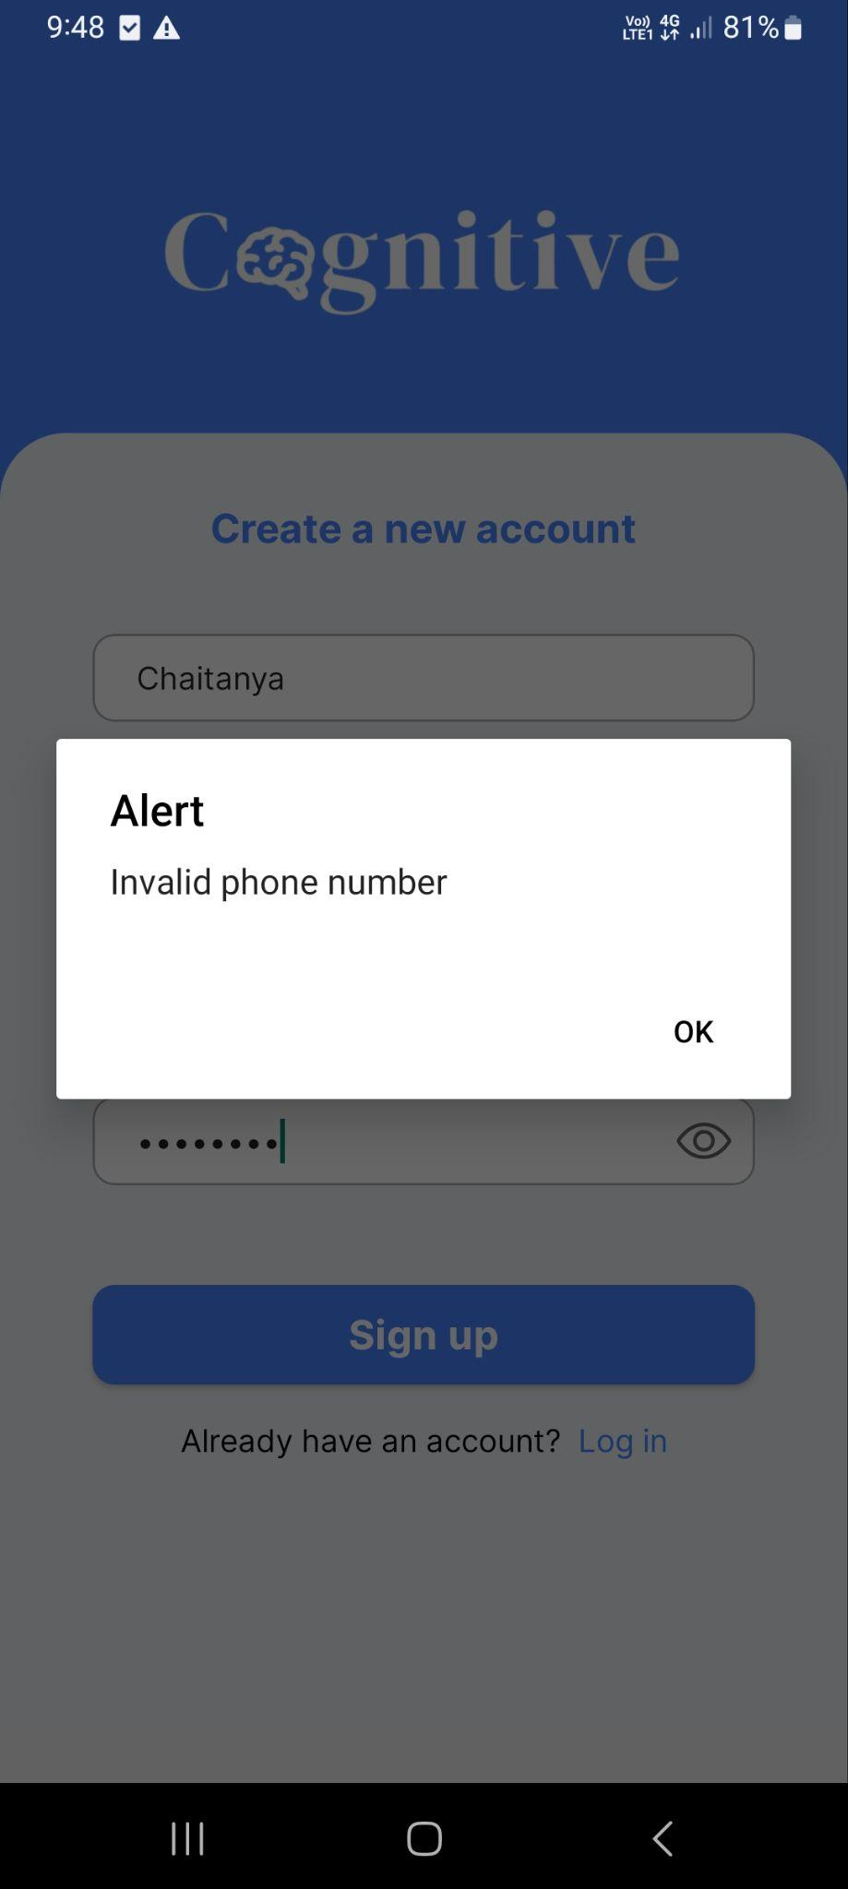

Fig.6.1 Test Case 1

Case 2: If the update details button is clicked then the profile should be updated according to the details as shown in figure 6.1

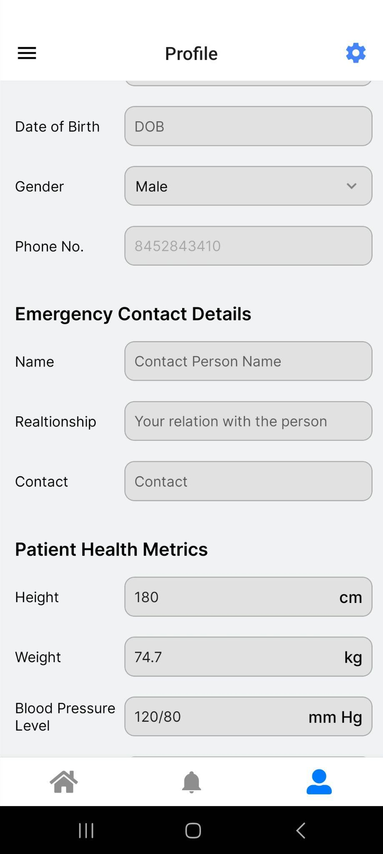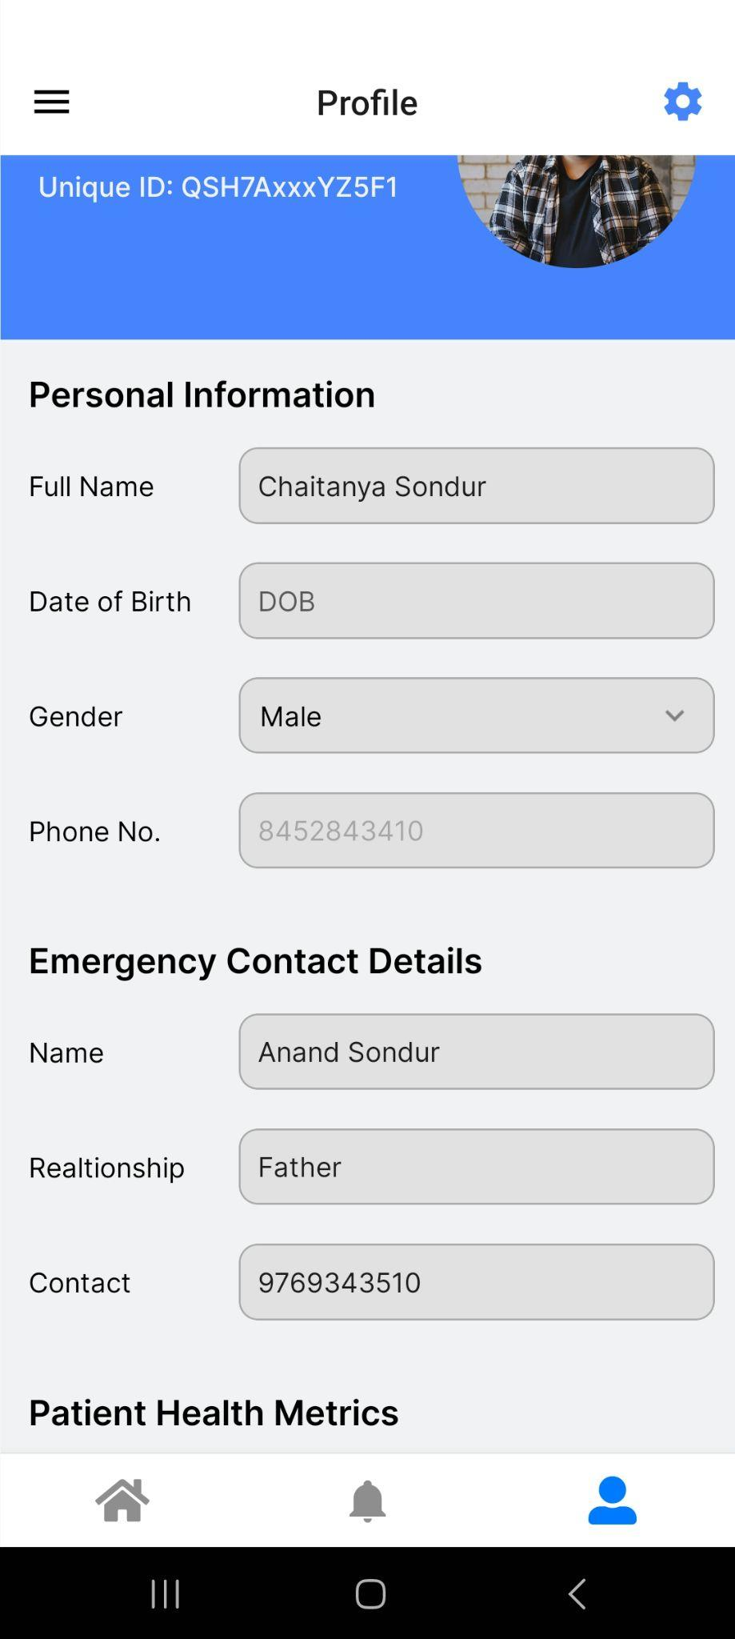

Fig. 6.2 Test case 2

Case 3: Verify that the stroke assessment questionnaire accurately collects demographic and health-related information, calculates stroke risk scores effectively as shown in fig. 6.3

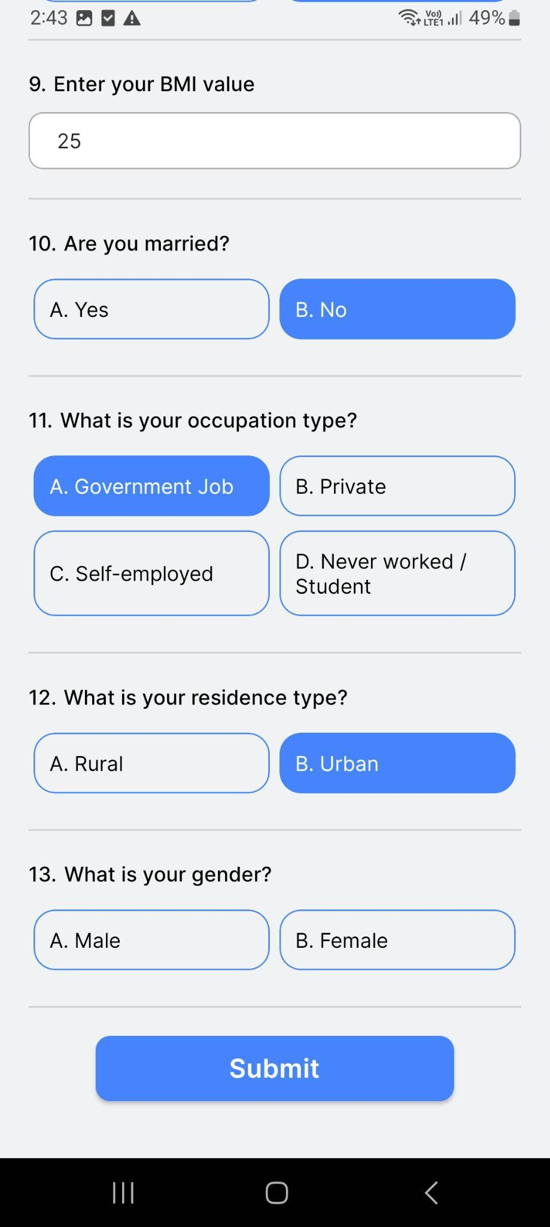

Fig. 6.3 Test Case 4

Case 4: UI and backend interactions for login functionality as shown as figure 6.4

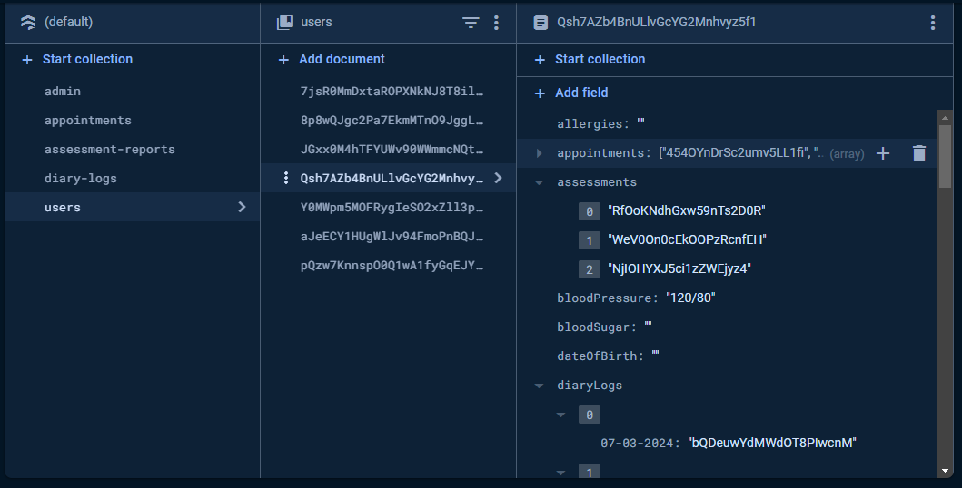

Fig. 6.4 Test case 4

## 6.4 Inference drawn from test cases

Case 1: The input field for 'phone number' should only accept valid 10-digit phone numbers. The user should not be able to enter an invalid format, such as alphabetic characters or special symbols.



Fig.6.5 Inference of test case 1

Case 2: If the update details button is clicked then the profile should be updated according to the details. This will allow the user to update his/her details if required like uploading a new resume, Adding some new skills etc.

 

Fig. 6.6 Inference of test case 2

Case 3 : The stroke assessment should prompt a stroke risk score scaling from 0 to 3

0 → No stroke

1 → Slight risk

2 → Moderate risk

3 → Severe risk

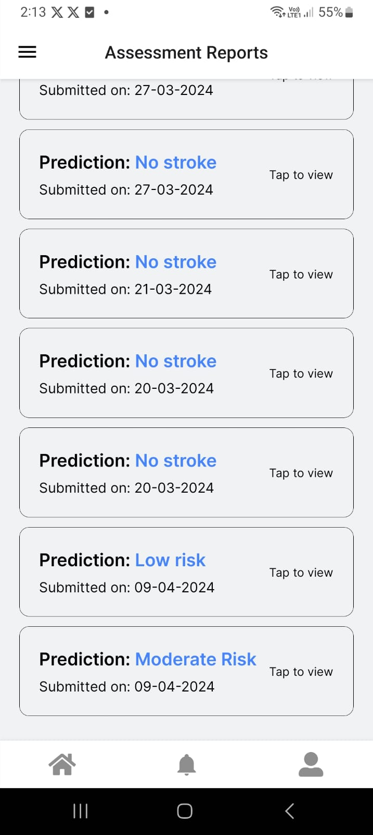

Fig. 6.7 Inference of test case 3

Case 4 :

New user registration entered on the UI should be updated according to the firebase backend.



Fig. 6.8 Inference of test case 4

# Chapter 7: Results and Discussions

## 7.1: Screenshots of UI for respective module

**Patient side**

The mobile application “Cognitive” has numerous functionalities. One such functionality is to predict the risk of stroke. The users’ are asked to fill a questionnaire which consists of questions related to their daily life like smoking status, marital status, etc. Then our machine learning algorithm predicts the stroke risk given the inputs by the user. The reports are then available under the “Assessment Reports” section as shown in Figure 7.1. Users can also view their selected options by clicking on the “Tap to view” button under each assessment. Our next functionality is regarding the diary logs. This requires users to fill a log everyday to track their progress as shown in figure 7.2. Score is assigned to each question and a graph is displayed on the dashboard for the past seven days to show the progress of the user.

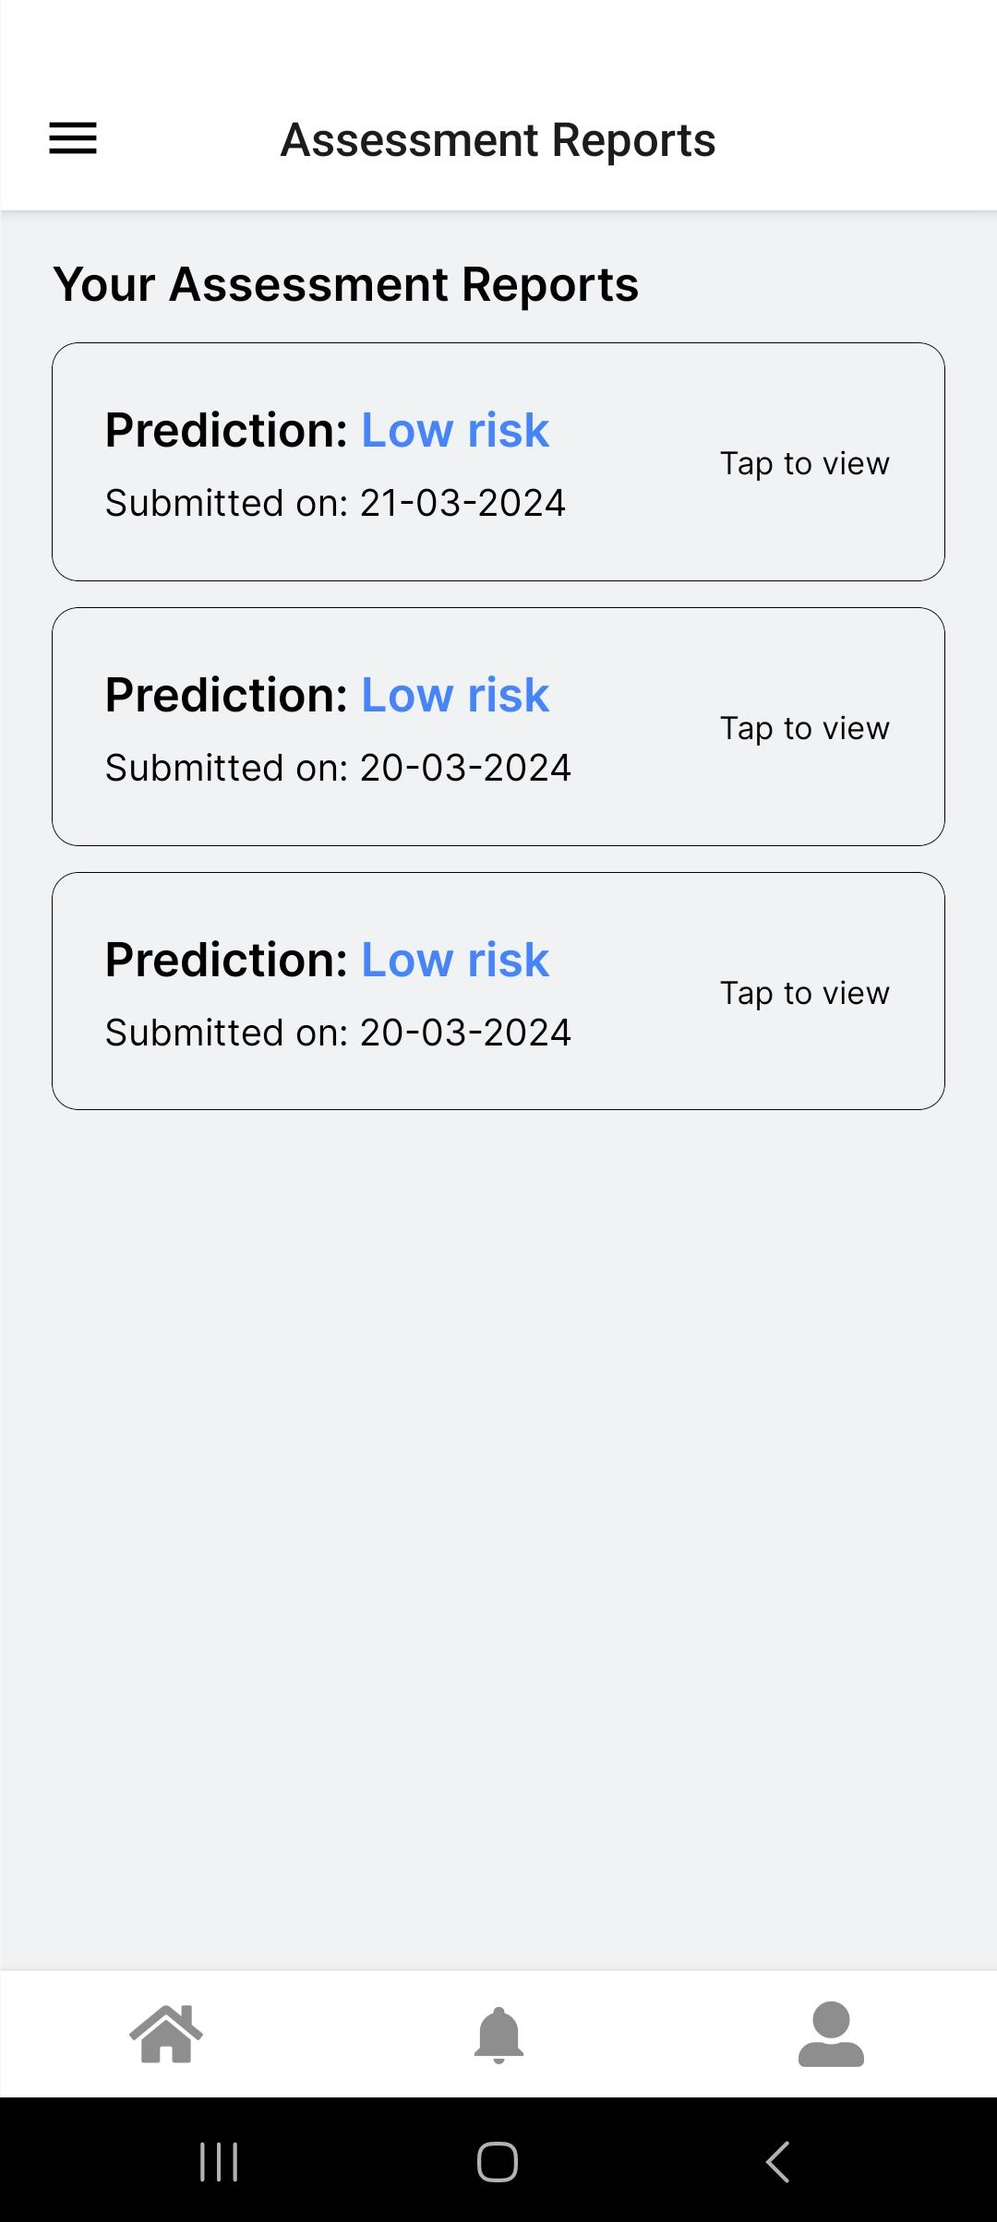 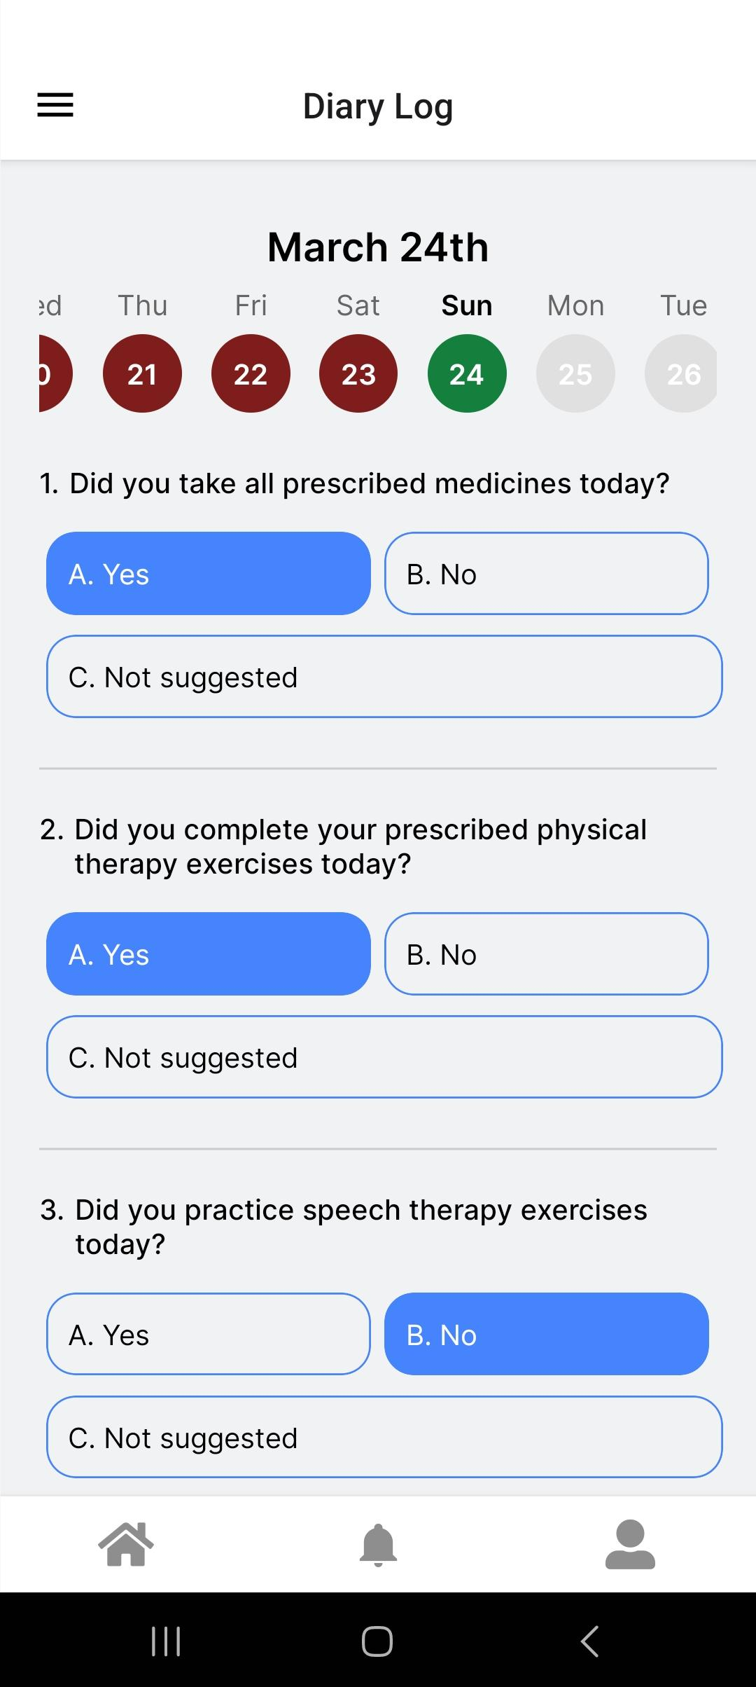

**Fig 7.1: Stroke assessment prediction Fig 7.2: Diary Logs For each day**

Another functionality is to schedule an appointment with the doctor. Users are required to mention the details like patient name, purpose of visit and date and time of appointment as shown in figure 7.3. The appointment is then scheduled and shown on the user’s dashboard and appointments section. The doctor has the provision to reschedule appointments. In the figure 7.4, we can view various features of the EHR section. Users can upload health related documents in the Health Records section which is private only to them. In the “Doctor Recommendations” section, patients’ can view the personalized recommendation prescribed by the doctor specifically for the patient.

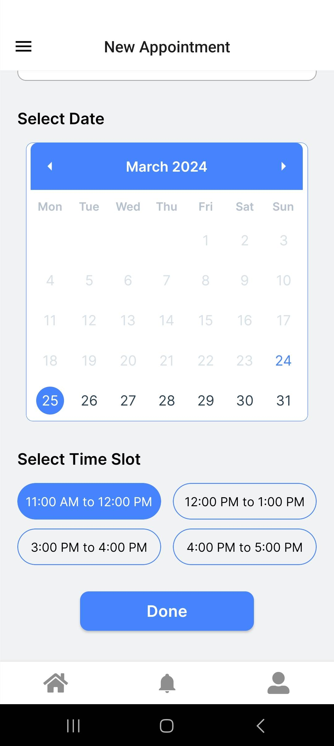 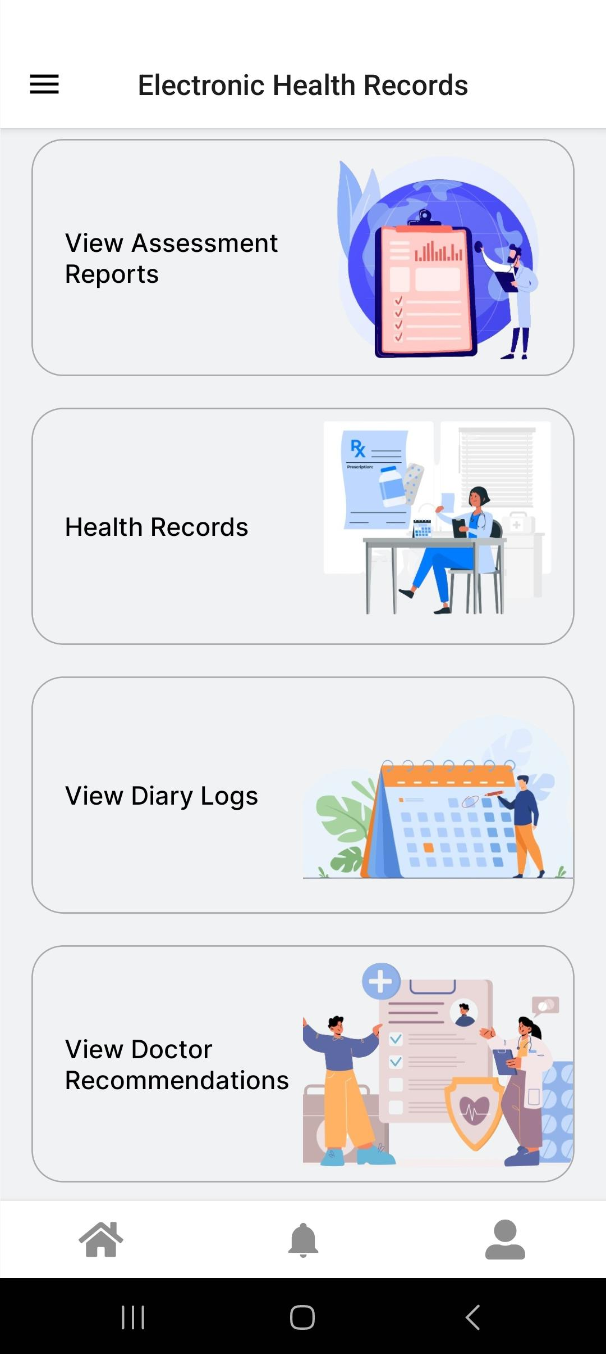

**Fig 7.3: Schedule an appointment with the doctor Fig 7.4: Electronic Health Records**

**Doctor side:**

Doctors will have the facility to add medicines for their patients. This can be done by visiting the profile section of a patient. The doctor has to enter details like medicine name, strength, frequency and when to take the medicine as shown in figure 7.5. One more functionality is to reschedule the appointment. Doctors have the option to reschedule the appointment if they are unavailable during that time and day. The doctor needs to modify the date and time as shown in the figure 7.6.

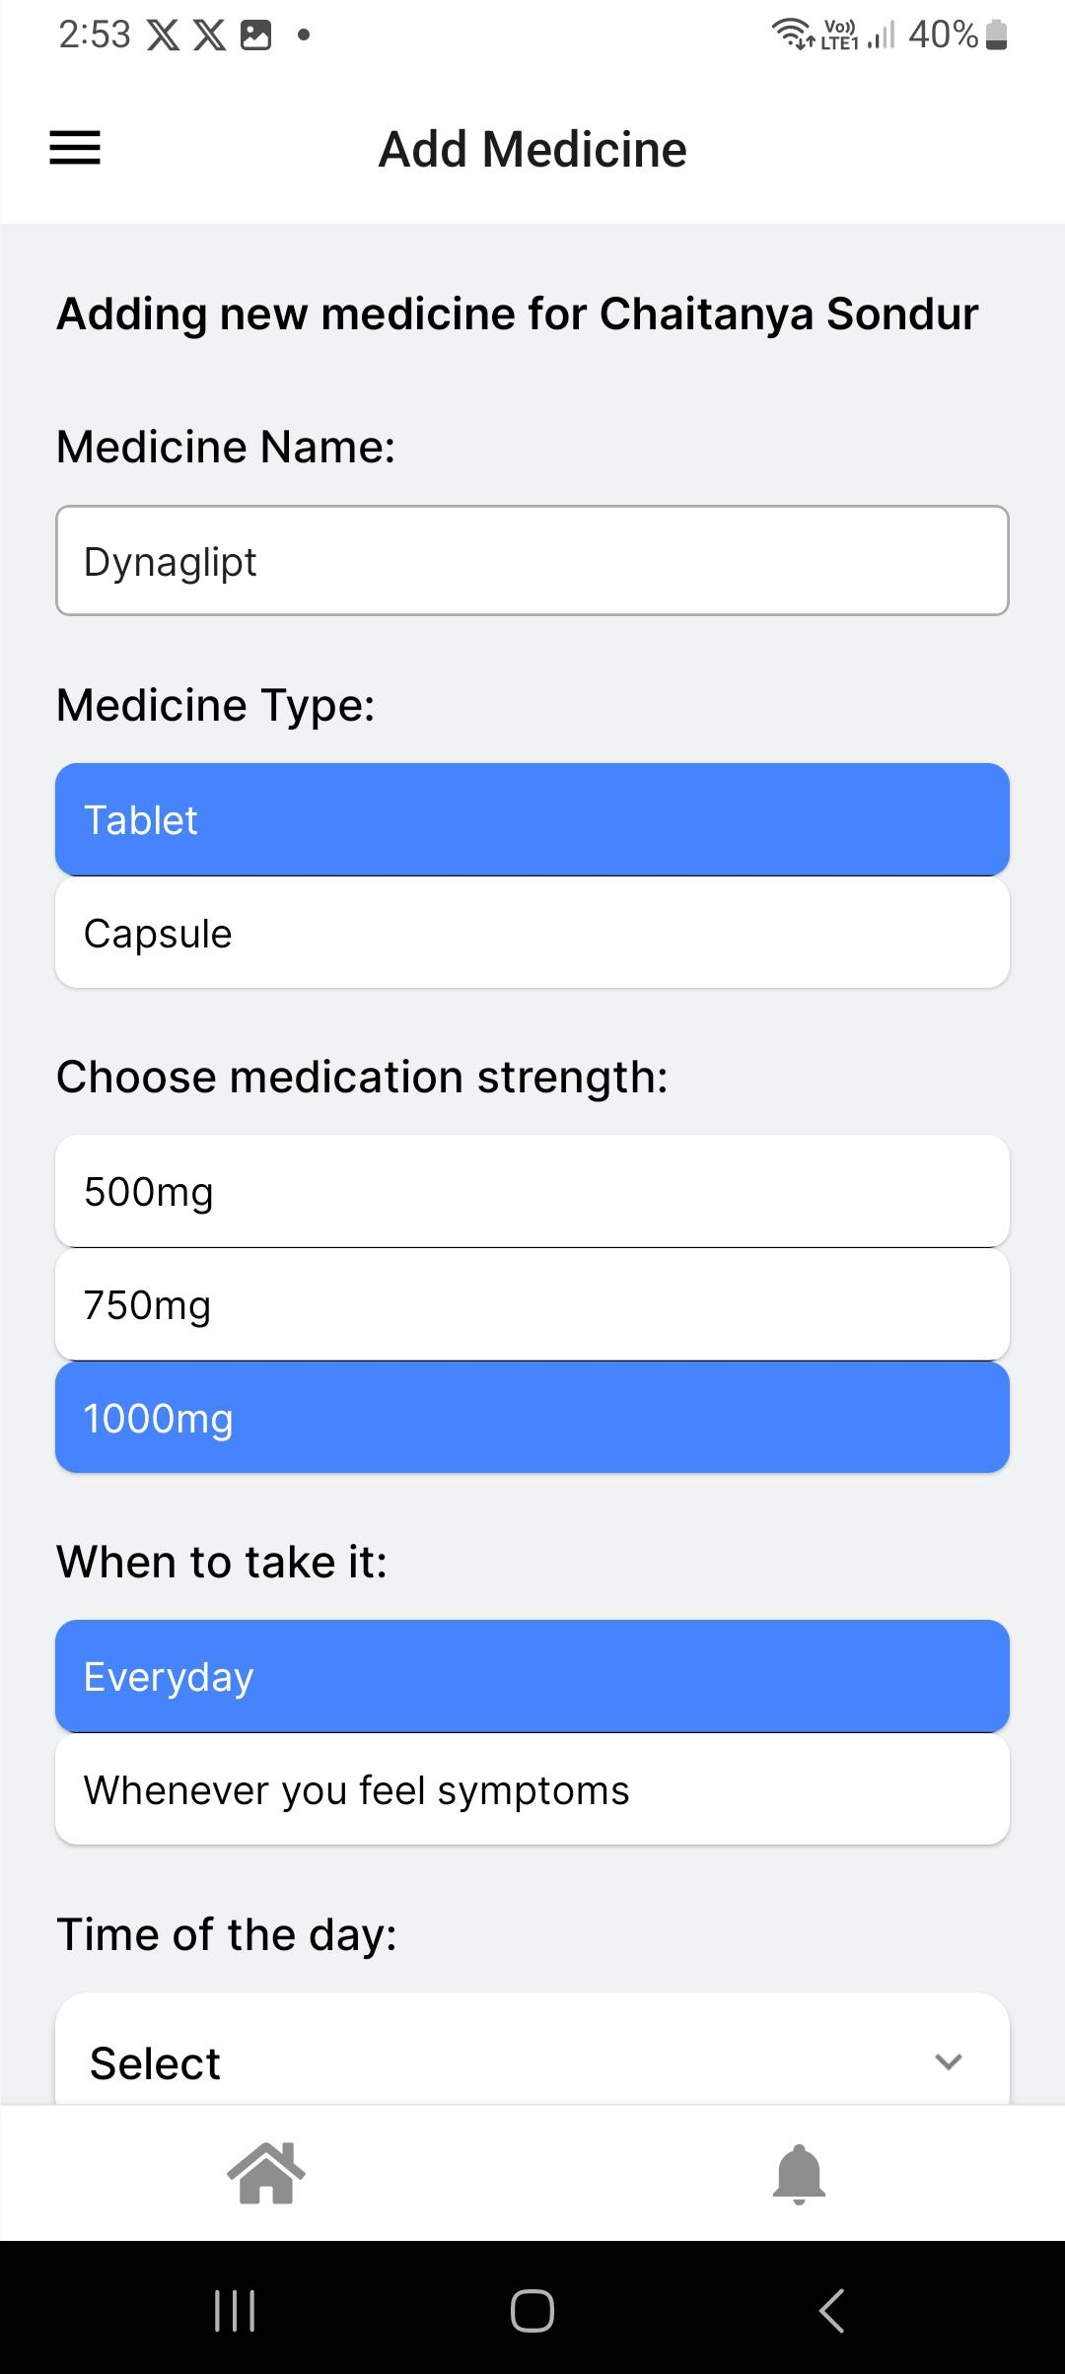 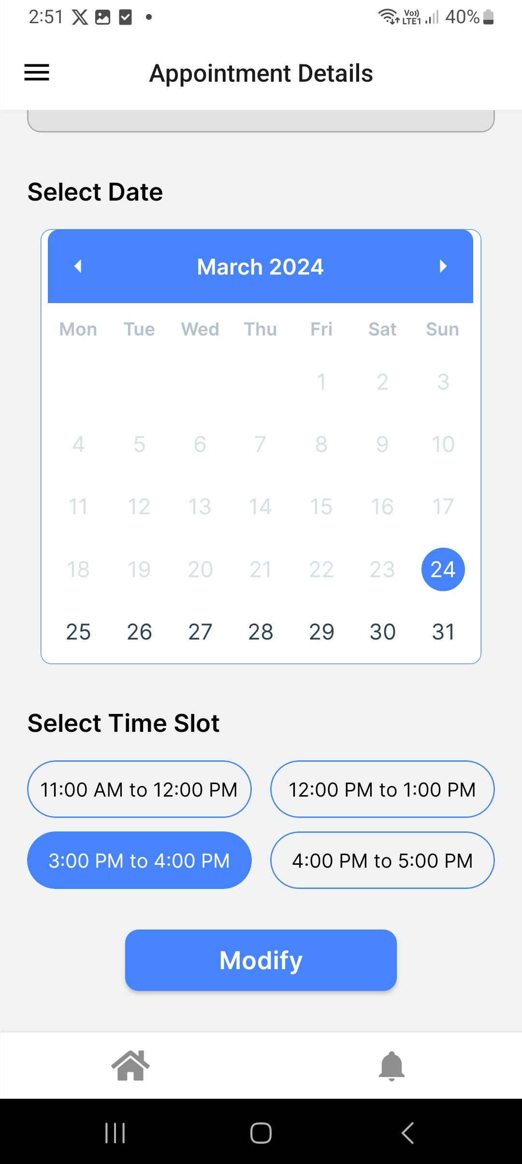

**Fig 7.5: Add Medicine functionality for the doctor Fig 7.6: Reschedule appointment**

## 7.2: Performance Evaluation measures

We observe in figure 7.7 that Random forest is the best performing algorithm than logistic regression with accuracy of 89.11% .Logistic regression is next best performing algorithm with an accuracy of 88.61%.

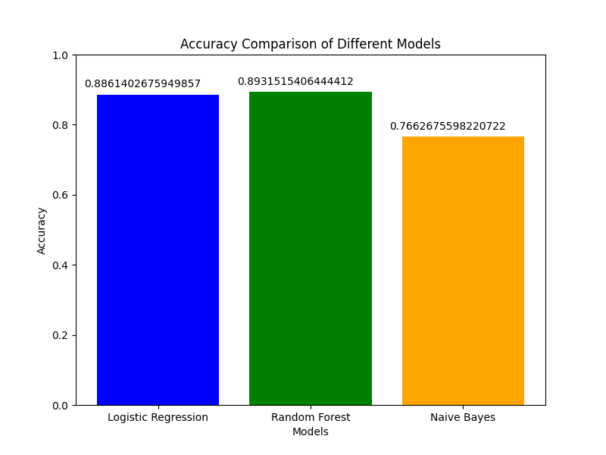

Fig. 7.7 Accuracy of All Models

The graph in figure 7.8 shows the connection between recall and precision for three different models: Random Forest, Logistic Regression, and Naive Bayes. Recall looks at how many relevant results the model finds, while precision looks at how many of the results the model found are actually relevant. The curves show how precision changes as recall changes. Higher precision means fewer false positives (irrelevant results), while higher recall means fewer false negatives (missing relevant results).Random Forest outperformed Logistic Regression and Naive Bayes, showing consistently higher precision levels across various recall values. With precision ranging from approximately 0.70 to 0.93 and recall from about 0.65 to 0.98, Random Forest demonstrated its superior ability to identify relevant instances while minimizing false positives.

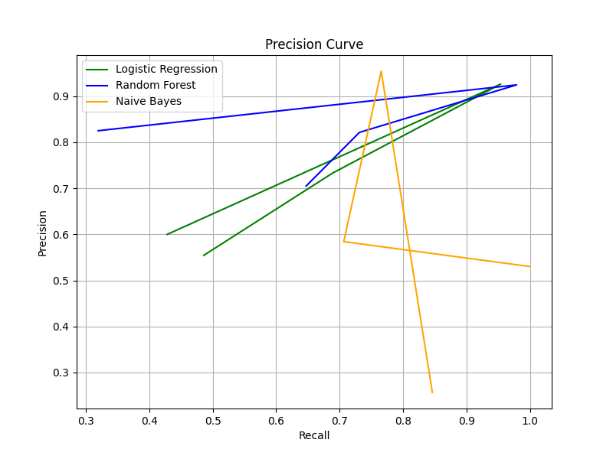

Fig 7.8 Precision-Recall Graph

**7.3: Input Parameters / Features considered**

In the process of feature engineering, all categorical values are transformed into numerical representations using dummy variables in Python. This conversion is essential because many machine learning algorithms require numerical input data. Following this, the data is scaled using the sklearn library, ensuring that all features are on a similar scale to prevent certain features from dominating others during model training. Subsequently, to identify the most important features for predictive modeling, three statistical methods—Mutual Information Score, Chi-Square Score, and ANOVA test—are employed. These methods help uncover the relationships between features and the target variable, guiding the selection of relevant features. From these analyses, the top 10 most important features are identified, including 'age', 'nihss', 'systolic', 'diastolic', 'glucose', 'smoking', 'bmi', 'ever_married_No', 'ever_married_Yes', 'work_type_children.

Visualization of the importance of different factors in predicting a health condition, like whether someone will have a stroke. The model assigns each factor a score based on how much it affects its predictions. Nihss score has the highest importance score, it means it's the most influential factor in predicting the health condition as shown in figure 7.9

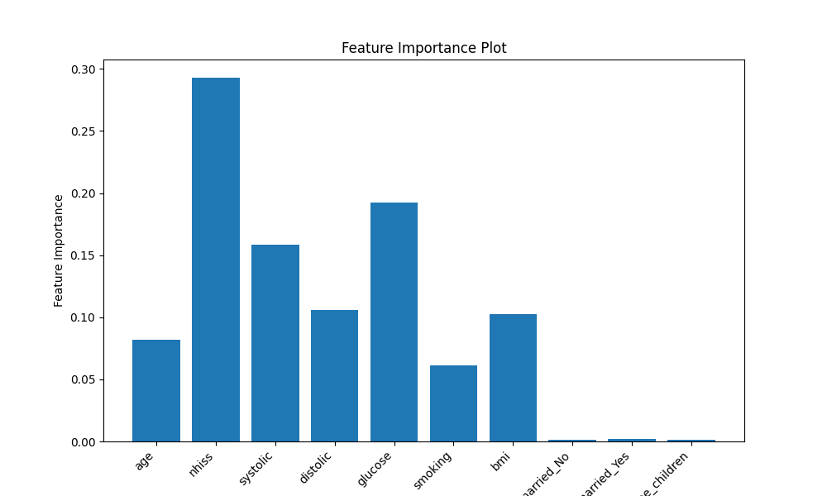

Fig. 7.9 Feature Selection

**7.4: Comparison of results with existing systems**

| Other System | Our System |
| --- | --- |
| Relies on local storage with limited scalability. | Utilizes Firebase Realtime Database for efficient data storage and retrieval, ensuring scalability and reliability |
| Accuracy is above 90%. | Accuracy is 89% |
| ANOVA F-value (Top 10 features) feature selection. | Not specified |
| Lacks integration with expert opinions for validation of ML predictions | Integrates expert opinions into the decision-making process to enhance the accuracy and reliability of predictions |

**7.5: Inference drawn**

The project aimed to revolutionize stroke care by developing a user-friendly CDSS mobile app. The primary goal was to streamline decision-making for healthcare providers and empower patients with personalized care plans. Leveraging the Random Forest algorithm, the app predicts stroke risk based on demographic and health data. For patients, it offers seamless navigation from stroke assessment to personalized care plans and appointment scheduling. Healthcare providers benefit from real-time support, alerts, and access to comprehensive patient profiles. Ultimately, the CDSS for stroke enhances the efficiency and effectiveness of stroke management, improving patient outcomes and healthcare delivery.

# 

# Chapter 8 : Conclusion

## 8.1 Limitation

1. **Data Availability:** The effectiveness of the mobile app heavily relies on the availability and accuracy of patient data, including medical history, demographic information, and risk factors. Limited access to comprehensive patient data could hinder the app's ability to provide accurate assessments and personalized advice.
2. **User Adoption:** The success of the mobile app depends on healthcare professionals' willingness to adopt and integrate it into their clinical workflow. Resistance to change or lack of familiarity with technology among healthcare providers may impede the widespread adoption of the Clinical Decision Support System (CDSS).
3. **Technical Constraints:** The mobile app's functionality and performance may be constrained by technical limitations such as device compatibility, network connectivity issues, and software bugs. Ensuring seamless operation across various mobile platforms and maintaining data security are additional challenges.

## 8.2 Conclusion

The application serves as a Clinical Decision Support System for patients and doctors where patients can take up risk assessment for stroke and the results will be sent to the expert, who will have the final say. Based on the result, the patient will be suggested to take action whether it is to follow a diet, perform certain exercises on a daily basis or consult the doctor. On consultation, medicines, exercises are suggested by the doctor until the follow-up. An Electronic Health Record system is maintained to store the data of patients such that it is readily available to the doctor.

## 8.3 Future Scope

1. **Integration of Blockchain based system for EHR**: Integrating blockchain technology into the mobile app's Electronic Health Record (EHR) system can enhance data security, integrity, and interoperability. Blockchain can provide a tamper-proof and decentralized platform for storing and sharing patient health records, ensuring transparency and privacy. Smart contracts on the blockchain can automate data access permissions and facilitate secure data exchanges between healthcare providers, patients, and researchers.
2. **Extend the use of application for multiple doctors**: Currently, the application supports the appointment scheduling and consulting of only one doctor. But, in the future this can be extended to multiple doctors related to stroke so that the patients would have a wider spectrum of choice of doctors and opinions to take .

**References**

[1] World Health Organization, “World Health Organization (WHO) Definition of Stroke,” Public Health, Aug. 17, 2020. https://www.publichealth.com.ng/world-health-organization-whodefinition-of-stroke/

[2] R. Brown, “Stroke - Symptoms and Causes,” Mayo Clinic, Dec. 08, 2023.

https://www.mayoclinic.org/diseasesconditions/stroke/symptoms-causes/syc-20350113

[3] National Institute of Neurological Disorders and Stroke, “Stroke,” www.ninds.nih.gov, Mar. 08, 2023. https://www.ninds.nih.gov/healthinformation/disorders/stroke

[4] L. Souza-Pereira, N. Pombo, S. Ouhbi, and V. Felizardo, “Clinical decision support systems for chronic diseases: A Systematic literature review,” Computer Methods and Programs in Biomedicine, vol. 195, p. 105565, Oct. 2020, doi: 10.1016/j.cmpb.2020.105565.

[5] S. Dev, H. Wang, C. S. Nwosu, N. Jain, B. Veeravalli, and D. John, “A predictive analytics approach for stroke prediction using machine learning and neural networks,” Healthcare Analytics, vol. 2, p. 100032, Nov. 2022, doi: 10.1016/j.health.2022.100032.

[6] T. Tazin, N. Alam, N. N. Dola, M. S. Bari, S. Bourouis, and M. M. Khan, “Stroke disease detection and prediction using robust learning approaches,” Journal of Healthcare Engineering, vol. 2021, pp. 1–12, Nov. 2021, doi: 10.1155/2021/7633381.

[7] C. S. Nwosu, S. Dev, P. Bhardwaj, B. Veeravalli, and D. John, “Predicting Stroke from Electronic Health Records,” Jul. 2019, doi: 10.1109/embc.2019.8857234.

[8] A. Bivard and M. Parsons, “Artificial intelligence for decision support in acute stroke current roles and potential,” Nature Reviews Neurology, vol. 16, no. 10, pp. 575–585, Aug. 2020, doi: 10.1038/s41582-0200- 390-y.

[9] E. M. Alanazi, A. Abdou, and J. Luo, “Predicting risk of stroke from lab tests using machine learning algorithms: Development and evaluation of prediction models,” JMIR Formative Research, vol. 5, no. 12, p. e23440, Dec. 2021, doi: 10.2196/23440.

[10] S. F. Alasiri, A. Douiri, S. Altukistani, T. Porat, and O. Mousa, ”The Role of Clinical Decision Support Systems in Preventing Stroke in Primary Care: A Systematic Review,” *Perspect Health Inf Manag.*, vol. 20, no. 2, p. 1d, Apr. 2023.

[11] M. Chun et al., “Stroke risk prediction using machine learning: a prospective cohort study of 0.5

million Chinese adults,” Journal of the American Medical Informatics Association, vol. 28, no. 8, pp.

1719–1727, May 2021, doi: 10.1093/jamia/ocab068.

[12] M. Saxena, M. Choudhary, M. Deep, S. Bhamra, and M. Maru, “Issue 4 www.jetir.org

(ISSN-2349-5162),” JETIR2204518 Journal of Emerging Technologies and Innovative Research, vol.

9, 2022.

[13] E. Akay, A. Hilbert, B. Carlisle, V. I. Madai, M. A. Mutke, and D. Frey, “Artificial Intelligence for Clinical Decision Support in Acute Ischemic Stroke: A Systematic Review,” vol. 54, no. 6, pp.

1505–1516, Jun. 2023, doi: https://doi.org/10.1161/strokeaha.122.041442.

[14] E. Dritsas and M. Trigka, “Stroke Risk Prediction with Machine Learning Techniques,” Sensors, vol. 22, no. 13, p. 4670, Jun. 2022, doi: https://doi.org/10.3390/s22134670.

[15] H. Abdu and G. Seyoum, “Sex Differences in Stroke Risk Factors, Clinical Profiles, and In-Hospital Outcomes Among Stroke Patients Admitted to the Medical Ward of Dessie Comprehensive Specialized Hospital, Northeast Ethiopia,” Degenerative Neurological and Neuromuscular Disease, vol. Volume 12,' pp. 133–144, Oct. 2022, doi: https://doi.org/10.2147/dnnd.s383564.

[16] “Automated Stroke Prediction Using Machine Learning: An Explainable and Exploratory Study With a Web Application for Early Intervention — IEEE Journals & Magazine — IEEE Xplore,” ieeexplore.ieee.org. https://ieeexplore.ieee.org/document/10130159

[17] L. Shahmoradi, R. Safdari, H. Ahmadi, and M. Zahmatkeshan, “Clinical decision support

systems-based interventions to improve medication outcomes: A systematic literature review on

features and effects,” Medical Journal of The Islamic Republic of Iran, vol. 35, no. 27, Apr. 2021, doi:

https://doi.org/10.47176/mjiri.35.27.

[18] T.-M. Chang, H.-Y. Kao, J.-H. Wu, and Y.-F. Su, “Improving physicians’ performance with a stroke CDSS: A cognitive fit design approach,” Computers in Human Behavior, vol. 54, pp. 577–586, Jan. 2016, doi: https://doi.org/10.1016/j.chb.2015.07.054.

**Appendix**

1. **Plagarism report**

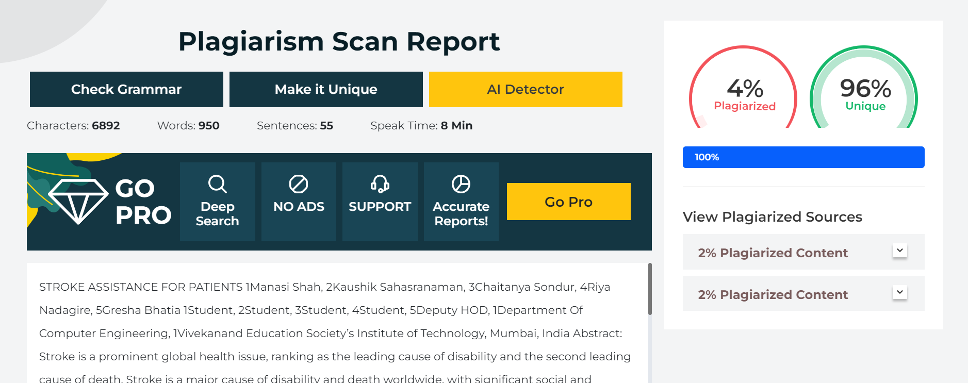

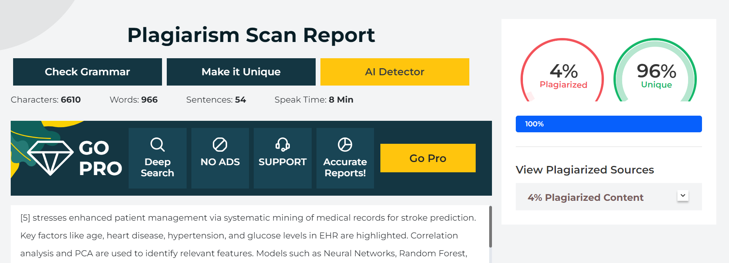

1. **Project Review sheets**

**Project Review Sheet 1 :**

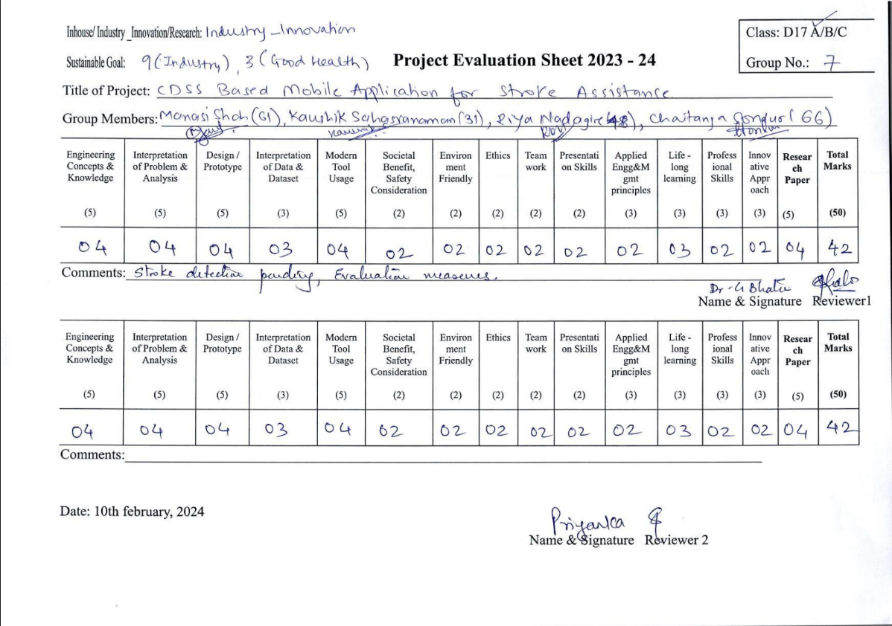

**Project Review Sheet 2**

